**A Project Report on**

**PRODUCT STOCK MANAGEMENT Application**

**Submitted as a mini-project**

By

Syed Shakeeb

Hall Ticket No: 160116733

Sohail Qureshi

Hall Ticket No: 160116733172

Under the guidance of

Smt.E.Swathi

Asst. Professor

Department of CSE,

CBIT, Hyderabad



**Department of Computer Science and Engineering**

**Chaitanya Bharathi Institute of Technology**

**Gandipet, Hyderabad – 500075**

**CERTIFICATE**

This is to certify that the project titled “Product stock Management Application” is a bona fide work carried out by Syed Shakeeb and Sohail Qureshi , in completion of a mini-project under our guidance and supervision.

The results embodied in this report have not been submitted to any other university or institute for the award of any degree or diploma.

Internal Guide :                                                                      Head of Department :

**Smt.E.Swathi**                                                                     **Dr.M. Swamy Das**

Asst. Professor                                                                       Professor and Head of

Department of CSE                                                                Department of CSE

CBIT, Hyderabad                                                                     CBIT, Hyderabad

**ACKNOWLEDGEMENTS**

I would like to express our heartfelt gratitude to Smt.E.Swathi , our project guide, for her invaluable guidance and constant support, along with her capable instruction and persistent encouragement.

I am grateful to our Head of Department, Dr. M . Swamy Das, for his steady support and the provision of every resource required for the completion of this project.

I would like to take this opportunity to thank our Principal, Dr. P. Ravinder Reddy, as well as the management of the institute, for having designed an excellent learning atmosphere.

My thanks are due to all members of the staff and our lab assistants for providing me with the help required to carry out the groundwork of this project.

**ABSTRACT**

This project has implemented an interactive general product stock management application, whose aims are to provide users with a smooth and uncomplicated experience, and to design an efficient system for the maintenance and delivery of results.

The programming language used in this project is JAVA , which is a wellknown and powerful language used in several  applications. The factors that contributed to the choice of this language shall be explained in detail in the chapters that follow.

Stock Management System is an application developed using Java

programming language. The main objective of this project is to manage a

stock for a company or organization, and take care of sales and purchase of

products. This project includes various modules and features to add, edit, view

and delete stock-management- related things in the system database.

The existing Stock Management procedure is a manual one which run with pen

and paper. It is very time consuming and uneconomical for an organization.

Data organization is not effective and efficient in the current system, and there

is more risk of data mismanagement.

To overcome the drawbacks and limitations of the existing system, this Stock

Management System is proposed. It is a more efficient application developed

using Java . This application is more effective for stock data management; the

data is more secured and can be accessed easily.

The information that can be added into the system are category, purchase,

sales print, stock details, stock entries, stock entries payments, stock sales,

and more. The system also allows the admin to check sales details, stock

details, supplier details, and more.

There is significant scope for improvement in the project, which shall be addressed in future modifications made to it by the author. These are discussed in detail in later chapters. Broadly, however, the changes to be made tend in the direction of an even better user experience, more efficient algorithms, and some interesting modifications to the kinds of questions the application currently supports.

**CONTENTS**

Acknowledgements

Abstract

1. Introduction

1.1 Motivation

1.2 Objective of the Project

1.3 Limitations of the Project

2. Literature Survey

2.1 Introduction

2.2 Existing System

2.3 Proposed System

3. Analysis

3.1 Software Requirement Specification

3.1.1 User Requirement

3.1.2 Software Requirement

3.1.3 Hardware Requirement

3.2 Flowchart

4. Implementation and Design

4.1 Introduction

4.2 Front-End

4.3 Design and Flow of the Graphical User Interface

5. Testing and Validation

5.1 Introduction

5.2 Design of Test Cases and Scenarios

5.3 Validation

5.4 Conclusion

6. Conclusion

References

Appendix – I

**CHAPTER 1**

**INTRODUCTION**

**1.1. Motivation**

The idea that motivated this project in the earliest stage of its creation was the desire to create something that was not just interesting and informative, but also useful to a diverse and wide range of users. The practicality and utility of a project are essential factors to keep in mind while creating any work that can be called engineering. Hence, the concept of a product stock management was formed, as it is one that is common enough to be required frequently by people, and important enough to need efficient and proper design.

With this end in mind, it was logically necessary to design an interface-based application, rather than simply a console-based program. It is the author’s belief that even though it is only the front-end of a project, the design of a user interface is of utmost importance to anyone who seeks to make a mark with their project.

It is also necessary to observe that JAVA, used in its version 1.8.0 here, has made this goal achievable and even enjoyable. Learning a new language and gaining enough proficiency in it to complete a project was one of the main goals of this project. JAVA, being widely used and of essence to the modern programmer who seeks to expand their horizons, was a rather obvious choice for this endeavour. JAVA, with its powerful yet simple syntax, its vast library of resources, and a vibrant and dedicated community of contributors, has enriched the world of programming to no end, and this project is a humble and miniscule part of that impact.

Further, the idea of levels was an attractive one, as it held the promise of making a product sock management interesting and appealing, as well as posing a challenge to the programmer. After deciding to implement a program, all the features it must offer were considered and decided.

In all of these ways, the project received its first start from the ground, and it is the author’s hope that it has accomplished all that it set out to accomplish.

**1.2. Objective of the Project**

As stated previously, the main objective of this project is to implement a product stock management application using JAVA, most notably JAVA’s Graphical User Interface (GUI) building package. The same objective allows users to have an interesting and smooth experience with the result of this project. This objective has been realised, in ways that are outlined in the chapters to come.

**1.3. Limitations of the Project**

At this stage, the author is aware of many requirements of the project that are yet to be fulfilled. The ideas discussed below shall be implemented in the near future, and the project shall be kept alive with regular updates and modifications, that change and improve both the front-end and the back-end.

One limitation is that once the product is saved in the product list it cannot be removed from the product list. There is requirement for additional program to remove the product from the product list.

A second limitation is that there is no large database attached to the backend of the project. Even though a file stored and provides the usernames and passwords required for user authentication, these are of a primitive form . There is a requirement for an efficient database, which can permanently store user information, and provide a complete history of user actions

These limitations, along with the general need to make the user interface more appealing and attractive than it already is, shall be implemented in future versions, along with any other potential areas for change that shall present themselves in the days to come.

**CHAPTER 2**

**LITERATURE SURVEY**

**2.1. Introduction**

This project has implemented an interactive general product stock management application, whose aims are to provide users with a smooth and uncomplicated experience, easy handling of the product , and to design an efficient system for the maintenance and delivery of results.

**2.2. Existing System**

Most product management applications present today offer multiple features such as product expiry , stock location , stock to be loaded in the next shipment etc. Most other applications also allow users to access the product location and quantity from their accounts. However, an integration of levels, user authentication, attractive user interface, intuitive controls, and an efficient and robust back-end, is rare to come across.

**2.3. Proposed System**

This project aims to combine a seamless user interface with a strong and robust backend. The user experience will be remarkably smooth, and the products can be easily added in the system, with only minimal modifications to the source code of the project. This means that the proposed system is quite versatile and adaptable to the user’s requirements. The proposed system will also provide a strong user authentication structure, which has an efficient database along with an easy-to-use interface view.

**CHAPTER 3**

**ANALYSIS**

**3.1. Software Requirement Specification**

**3.2.1. User Requirements**

The user in this project is required to enter login details, and enter the product details and add it to the product list. From the interface point-of view, efforts have been made to keep the application as simple and user-friendly as possible.

**3.2.2. Software Requirements**

Any 32-bit or 64-bit operating system that supports JAVA , JAVA installation (version 1.8.0 ) . A console with access to the JAVA interpreter Support for Graphical User Interfaces (GUIs)

**3.2.3. Hardware Requirements**

Input device to answer questions and select options. 32-bit or 64-bit processor Sufficient RAM to run the program

**CHAPTER 4**

**IMPLEMENTATION AND DESIGN**

**4.1. Introduction**

The program used is in Java (version 1.8.140) with Java awt and swing and also event Handling package. The basic functionality of the program lies in asking from the user for the input of the Product Name, SKU and etc and storing it in the Product Table List.

The front-end of the program are both Java, with the former implementing the user interface components from the awt and swing package, and the latter making use of several functions.

These are both explored in this section.

**4.2. Front-End**

The front-end of the project is the user interface that has been designed using widgets. Awt and Swing offers many components, out of which the Label, Button, Radiobutton, and Table have been used in this project. These components together constitute the front-end.

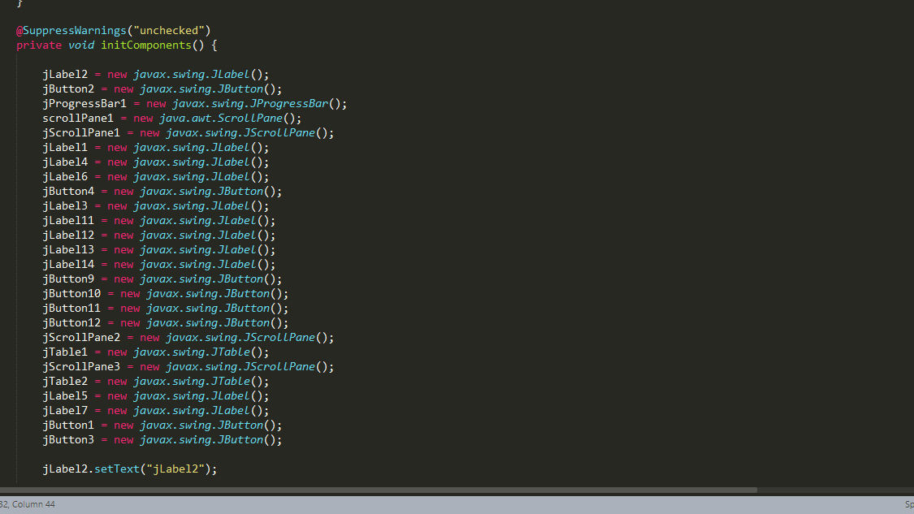

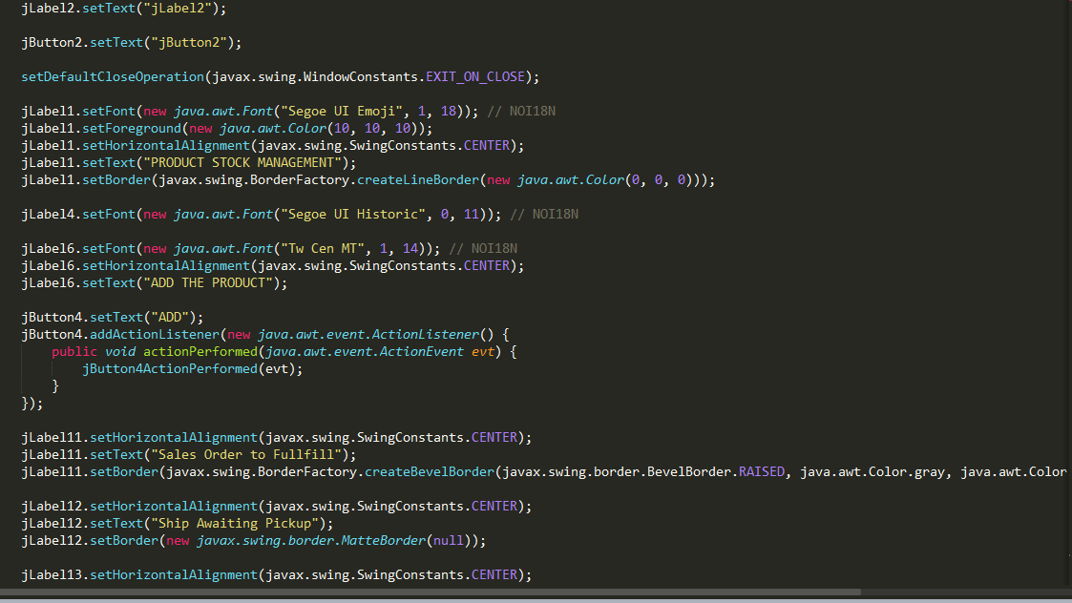

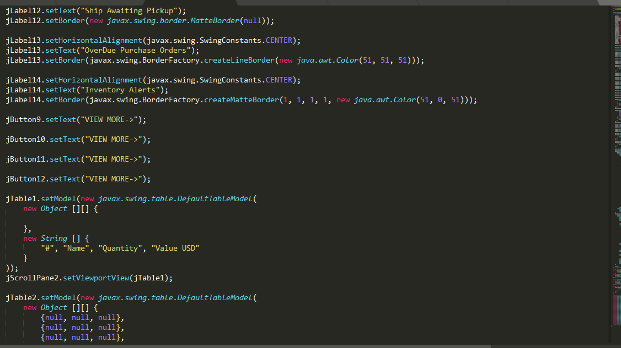

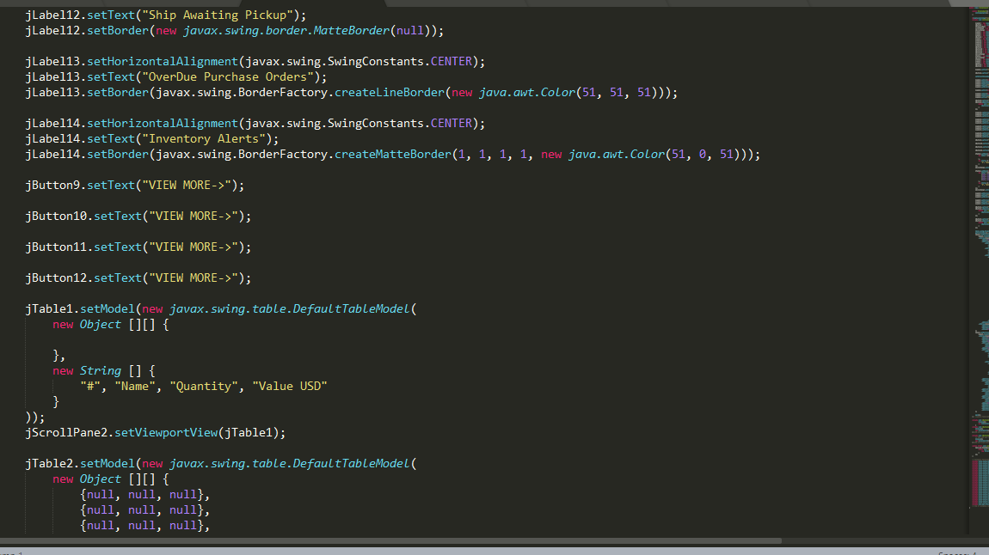

**Front-End**

**4.2.1 Labels**

Labels are the simplest componenets in the awt and Swing Application, used to display text at a specified location in the application.

|  |  |  |
| --- | --- | --- |
| **S.No** | **Labels** | **Functionality** |
| 1 | JLabel1 | Display the Tittle |
| 2 | JLabel6 | Asks the User to Add the Product |
| 3 | JLabel3 | Asks the product to enter the Login Id |
| 4 | JLabel4 | Asks the user to enter the Password |
| 5 | JLabel2 | Asks the user to enter the First Name |
| 6 | JLabel3 | Asks the user to enter the Last Name |
| 7 | JLabel4 | Asks the user the enter the e-mail |
| 8 | JLabel5 | Asks the user to enter the Pssword |
| **9** | JLabel12 | Asks the user to enter the Product Name |
| 10 | JLabel13 | Asks the user to enter the Product SKU |
| 11 | JLabel14 | Asks the User to enter the Price |
| 12 | JLabel15 | Asks the User to enter the Description |

**4.2.2 Buttons**

Buttons in swing package are associated with commands that they need to execute when pressed.

|  |  |
| --- | --- |
| JButton | Description |
| JButton2 | Allows the User to tranfer the Product to JTable |
| JButton4 | Allows the User to Add the Product |
| JButton1 | Allows the User to join as a New User |
| JButton3 | Allows the User to Login |

**4.2.3 JTextField**

JTextField in Swing Package are used to accept text from the user in the form of a text field.

|  |  |  |
| --- | --- | --- |
| **S.No** | **JTextField** | **Description** |
| 1 | JTextField1 | Allows us to enter the Login Id |
| 2 | JTextField1 | Allows us to enter the First Name |
| 3 | JTextField2 | Allows us to enter the Last Name |
| 4 | JTextField3 | Allows us to enter the e-mail Address |
| 5 | JTextField9 | Allows us to enter the Product Name |
| 6 | JTextField10 | Allows us to enter the Product SKU |
| 7 | JTextField11 | Allows us to enter the Price USD |
| 8 | JTextField12 | Allows us to enter the Description |

**4.2.4 JPassword**

JPassword is the swing Componenet which allows us to enter the Password.

|  |  |  |
| --- | --- | --- |
| **S.No** | **JPasswordField** | **Description** |
| 1 | JPasswordField1 | Allows the user to enter the Password |

**4.2.5 JTable**

JTable is the swing Component in Java which allows us to store the values in Row and Column.

|  |  |  |
| --- | --- | --- |
| **S.no** | **JTable** | **Description** |
| 1 | JTable1 | Allows the user to store the values of the Product |
| 2 | JTable1 | Allows the user to see the Top 10 Cities and 10 Selling Products |

**4.2.6 JComboBox**

JComboBox is the swing component which drops down like a message from which we can select the Item from it

|  |  |  |
| --- | --- | --- |
| **S.no** | **JComboBox** | **Description** |
| 1 | JComboBox1 | Allows the user to select the Message |
| 2 | JComboBox | Allows the user to select the Date |

**4.3. Design and Flow of the Graphical User Interface**

The introductory screen looks as follows:

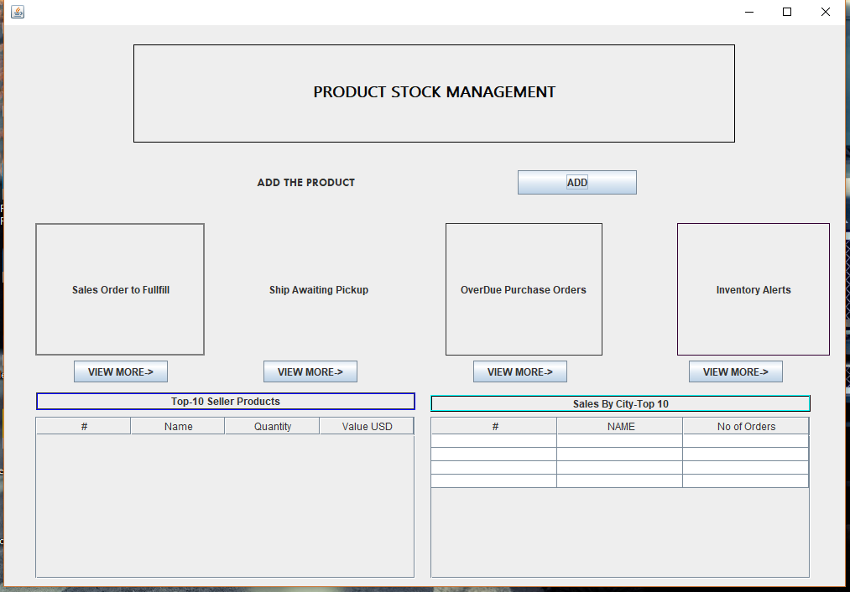

On Clicking the Add the Product

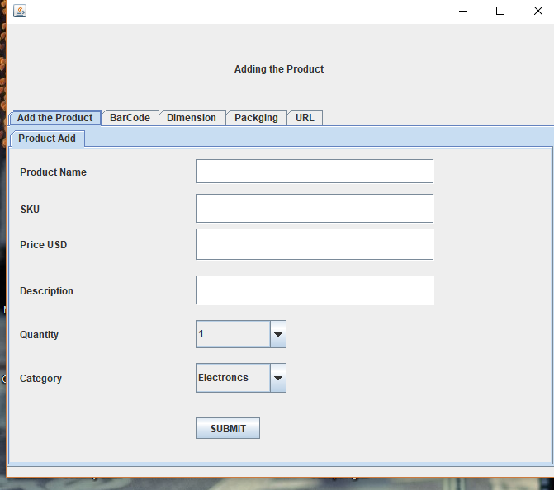

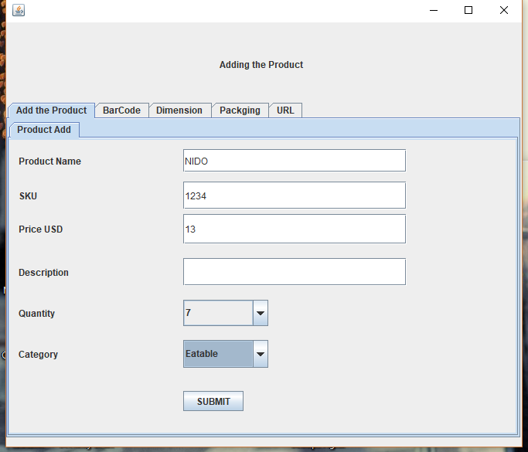

When Clicking the Submit Button it will redirect you to JTable

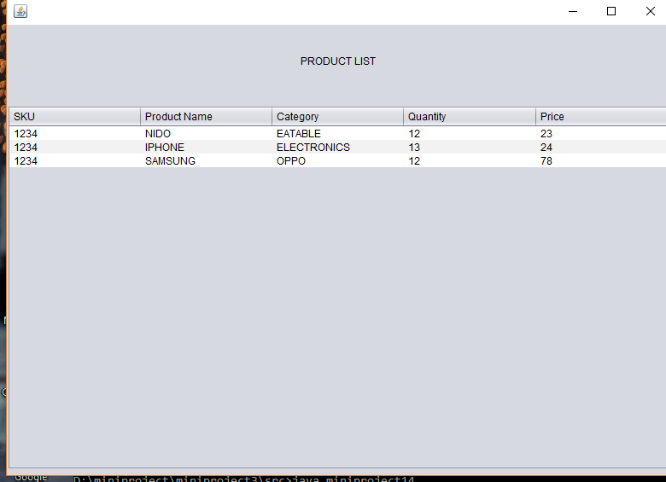

It have also Additional Features

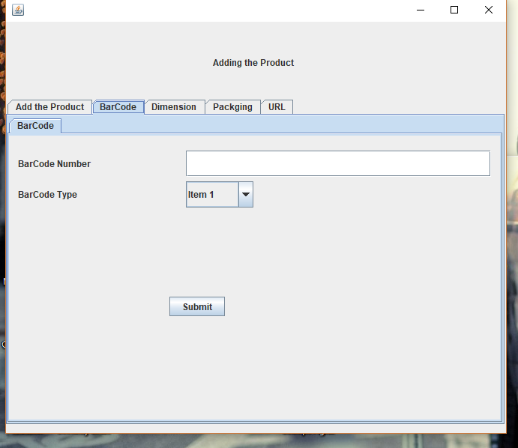

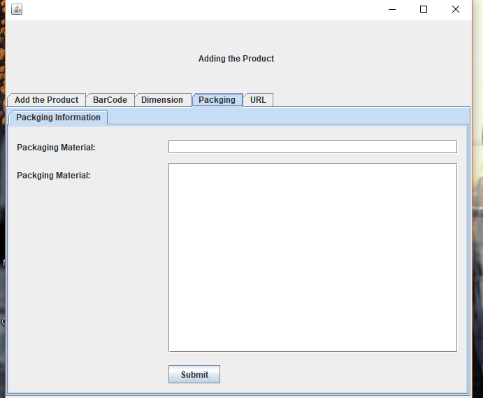

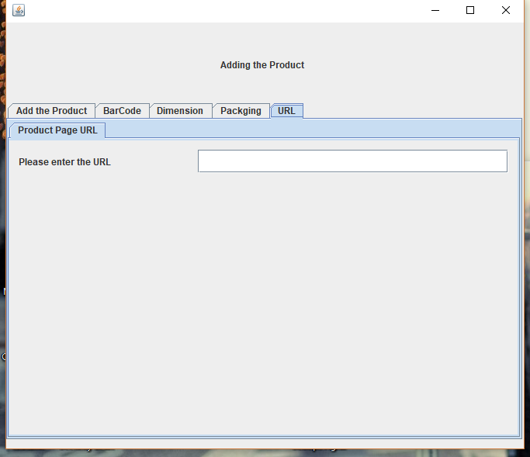

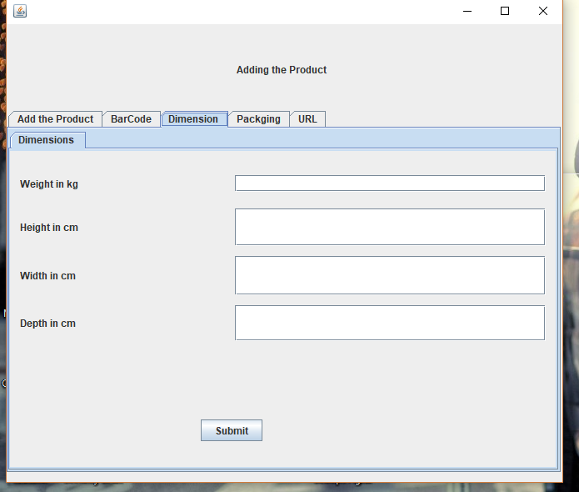

It will have two features LOGIN and New User



On Clicking Login

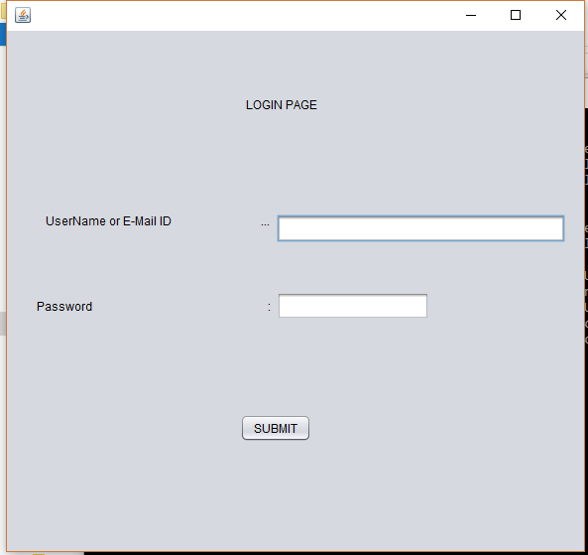

On Entering all the necessary Details then then the message comes up

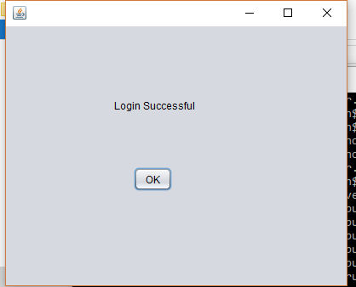

On Clicking New User

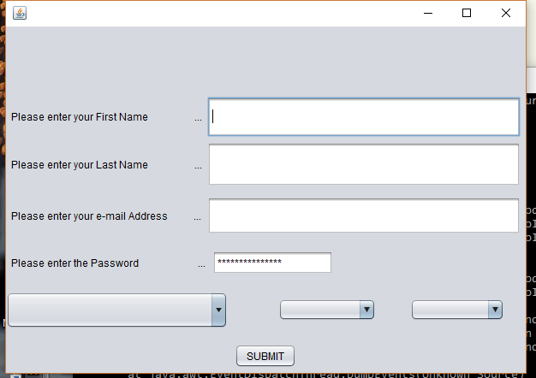

On clicking the details then the message pops up

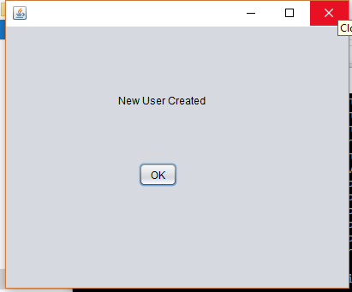

**CHAPTER 5**

**TESTING AND VALIDATION**

**5.1. Introduction**

Testing and validation of the program is a crucial part of project. It is impossible to determine all of the exceptional cases that might arise during the design of the program. Hence testing serves as a useful way to find the flaws in both the structure of the program and the implementation of the various functions.

**5.2. Design of Test Cases and Scenarios**

The test cases were designed keeping in mind where the program is liable to fail and throw errors or give erroneous outputs. The following cases are some of the important scenarios to be kept in mind.

**5.2.1. Registration with existing username**

If the user tries to register with a username that already belongs to another user, the following message box pops up stating that the username does not exist.

**5.2.2 Wrong login credentials**

If the username and password don’t match, or no such username has been registered, the following message box pops up that the login failed.

**5.2.3 When the Product name and SKU is same**

If the Product Name and SKU(Serial Number of the Product) then the following message pops up that the product name and SKU(serial number is same).

**5.3. Validation**

The program was validated by running a test case with some correct answers and wrong answers, as well as both wrong and correct login credentials and product name and SKU. Care was taken to include all possible exceptional cases and other problematic scenarios in the input.

**5.4. Conclusion**

After extensive testing and the final validation, it was concluded that the project is successful in carrying out all the functionalities mentioned throughout this report.

**CHAPTER 6**

**CONCLUSION AND FUTURE ENHANCEMENT**

As mentioned elsewhere in this report, the objective of this project was to implement a smooth and efficient product stock management software that is easy to use for users and programmers alike.

This objective has been accomplished in the course of creating this project.

The author would like to conclude that the project has achieved what it set out to accomplish, even though there will always be areas for potential improvement and enhancement. Both the limitations and shortcomings of this project have been outlined in a previous chapter.

As stated above, there is considerable scope for improvement, and many changes can be made to enhance this project. These include a smoother user interface, and a way to integrate the project with the using either of Python’s Web frameworks.

**REFERENCES**

1.<https://www.codecademy.com/learn/learn-java>

2.<http://www.learnjavaonline.org/>

3.<http://www.youtube.com>

4.<https://www.tutorialspoint.com/java/>

5.[http://www.wikipedia.com/product stockmanagement/](http://www.wikipedia.com/product%20stockmanagement/)

6.<http://www.Delivrd.com>

7.<https://www.udemy.com/java-tutorial/>

8. <https://www.sololearn.com/Course/Java/>

9. <https://www.codementor.io/collections/learn-java-bwbbwjibt>

**APPENDIX – I**

**PROGRAM**

public class Miniproject3 extends javax.swing.JFrame {

public Miniproject3() {

initComponents();

}

@SuppressWarnings("unchecked")

private void initComponents() {

jLabel2 = new javax.swing.JLabel();

jButton2 = new javax.swing.JButton();

jProgressBar1 = new javax.swing.JProgressBar();

scrollPane1 = new java.awt.ScrollPane();

jScrollPane1 = new javax.swing.JScrollPane();

jLabel1 = new javax.swing.JLabel();

jLabel4 = new javax.swing.JLabel();

jLabel6 = new javax.swing.JLabel();

jButton4 = new javax.swing.JButton();

jLabel3 = new javax.swing.JLabel();

jLabel11 = new javax.swing.JLabel();

jLabel12 = new javax.swing.JLabel();

jLabel13 = new javax.swing.JLabel();

jLabel14 = new javax.swing.JLabel();

jButton9 = new javax.swing.JButton();

jButton10 = new javax.swing.JButton();

jButton11 = new javax.swing.JButton();

jButton12 = new javax.swing.JButton();

jScrollPane2 = new javax.swing.JScrollPane();

jTable1 = new javax.swing.JTable();

jScrollPane3 = new javax.swing.JScrollPane();

jTable2 = new javax.swing.JTable();

jLabel5 = new javax.swing.JLabel();

jLabel7 = new javax.swing.JLabel();

jButton1 = new javax.swing.JButton();

jButton3 = new javax.swing.JButton();

jLabel2.setText("jLabel2");

jButton2.setText("jButton2");

setDefaultCloseOperation(javax.swing.WindowConstants.EXIT_ON_CLOSE);

jLabel1.setFont(new java.awt.Font("Segoe UI Emoji", 1, 18)); // NOI18N

jLabel1.setForeground(new java.awt.Color(10, 10, 10));

jLabel1.setHorizontalAlignment(javax.swing.SwingConstants.CENTER);

jLabel1.setText("PRODUCT STOCK MANAGEMENT");

jLabel1.setBorder(javax.swing.BorderFactory.createLineBorder(new java.awt.Color(0, 0, 0)));

jLabel4.setFont(new java.awt.Font("Segoe UI Historic", 0, 11)); // NOI18N

jLabel6.setFont(new java.awt.Font("Tw Cen MT", 1, 14)); // NOI18N

jLabel6.setHorizontalAlignment(javax.swing.SwingConstants.CENTER);

jLabel6.setText("ADD THE PRODUCT");

jButton4.setText("ADD");

jButton4.addActionListener(new java.awt.event.ActionListener() {

public void actionPerformed(java.awt.event.ActionEvent evt) {

jButton4ActionPerformed(evt);

}

});

jLabel11.setHorizontalAlignment(javax.swing.SwingConstants.CENTER);

jLabel11.setText("Sales Order to Fullfill");

jLabel11.setBorder(javax.swing.BorderFactory.createBevelBorder(javax.swing.border.BevelBorder.RAISED, java.awt.Color.gray, java.awt.Color.gray, java.awt.Color.gray, java.awt.Color.gray));

jLabel12.setHorizontalAlignment(javax.swing.SwingConstants.CENTER);

jLabel12.setText("Ship Awaiting Pickup");

jLabel12.setBorder(new javax.swing.border.MatteBorder(null));

jLabel13.setHorizontalAlignment(javax.swing.SwingConstants.CENTER);

jLabel13.setText("OverDue Purchase Orders");

jLabel13.setBorder(javax.swing.BorderFactory.createLineBorder(new java.awt.Color(51, 51, 51)));

jLabel14.setHorizontalAlignment(javax.swing.SwingConstants.CENTER);

jLabel14.setText("Inventory Alerts");

jLabel14.setBorder(javax.swing.BorderFactory.createMatteBorder(1, 1, 1, 1, new java.awt.Color(51, 0, 51)));

jButton9.setText("VIEW MORE->");

jButton10.setText("VIEW MORE->");

jButton11.setText("VIEW MORE->");

jButton12.setText("VIEW MORE->");

jTable1.setModel(new javax.swing.table.DefaultTableModel(

new Object [][] {

},

new String [] {

"#", "Name", "Quantity", "Value USD"

}

));

jScrollPane2.setViewportView(jTable1);

jTable2.setModel(new javax.swing.table.DefaultTableModel(

new Object [][] {

{null, null, null},

{null, null, null},

{null, null, null},

{null, null, null}

},

new String [] {

"#", "NAME", "No of Orders"

}

));

jScrollPane3.setViewportView(jTable2);

jLabel5.setHorizontalAlignment(javax.swing.SwingConstants.CENTER);

jLabel5.setText("Top-10 Seller Products");

jLabel5.setBorder(javax.swing.BorderFactory.createEtchedBorder(javax.swing.border.EtchedBorder.RAISED, java.awt.Color.darkGray, java.awt.Color.blue));

jLabel7.setHorizontalAlignment(javax.swing.SwingConstants.CENTER);

jLabel7.setText("Sales By City-Top 10");

jLabel7.setBorder(javax.swing.BorderFactory.createEtchedBorder(java.awt.Color.black, java.awt.Color.cyan));

jButton1.setText("LOGIN");

jButton1.addActionListener(new java.awt.event.ActionListener() {

public void actionPerformed(java.awt.event.ActionEvent evt) {

jButton1ActionPerformed(evt);

}

});

jButton3.setText("NEW USER");

jButton3.addActionListener(new java.awt.event.ActionListener() {

public void actionPerformed(java.awt.event.ActionEvent evt) {

jButton3ActionPerformed(evt);

}

});

javax.swing.GroupLayout layout = new javax.swing.GroupLayout(getContentPane());

getContentPane().setLayout(layout);

layout.setHorizontalGroup(

layout.createParallelGroup(javax.swing.GroupLayout.Alignment.LEADING)

.addGroup(layout.createSequentialGroup()

.addGap(37, 37, 37)

.addGroup(layout.createParallelGroup(javax.swing.GroupLayout.Alignment.LEADING)

.addGroup(layout.createSequentialGroup()

.addGap(584, 584, 584)

.addComponent(jLabel4, javax.swing.GroupLayout.DEFAULT_SIZE, javax.swing.GroupLayout.DEFAULT_SIZE, Short.MAX_VALUE))

.addGroup(javax.swing.GroupLayout.Alignment.TRAILING, layout.createSequentialGroup()

.addGap(0, 0, Short.MAX_VALUE)

.addComponent(jLabel6, javax.swing.GroupLayout.PREFERRED_SIZE, 190, javax.swing.GroupLayout.PREFERRED_SIZE)

.addGap(536, 536, 536))

.addGroup(layout.createSequentialGroup()

.addGroup(layout.createParallelGroup(javax.swing.GroupLayout.Alignment.LEADING)

.addGroup(layout.createParallelGroup(javax.swing.GroupLayout.Alignment.TRAILING, false)

.addGroup(javax.swing.GroupLayout.Alignment.LEADING, layout.createSequentialGroup()

.addGap(40, 40, 40)

.addComponent(jLabel3))

.addGroup(javax.swing.GroupLayout.Alignment.LEADING, layout.createSequentialGroup()

.addGroup(layout.createParallelGroup(javax.swing.GroupLayout.Alignment.TRAILING)

.addComponent(jLabel5, javax.swing.GroupLayout.PREFERRED_SIZE, 452, javax.swing.GroupLayout.PREFERRED_SIZE)

.addComponent(jScrollPane2, javax.swing.GroupLayout.PREFERRED_SIZE, javax.swing.GroupLayout.DEFAULT_SIZE, javax.swing.GroupLayout.PREFERRED_SIZE)

.addComponent(jButton1))

.addPreferredGap(javax.swing.LayoutStyle.ComponentPlacement.UNRELATED)

.addGroup(layout.createParallelGroup(javax.swing.GroupLayout.Alignment.LEADING, false)

.addComponent(jScrollPane3)

.addComponent(jLabel7, javax.swing.GroupLayout.DEFAULT_SIZE, javax.swing.GroupLayout.DEFAULT_SIZE, Short.MAX_VALUE)

.addComponent(jButton3)))

.addGroup(layout.createSequentialGroup()

.addGap(46, 46, 46)

.addComponent(jButton9)

.addPreferredGap(javax.swing.LayoutStyle.ComponentPlacement.RELATED, javax.swing.GroupLayout.DEFAULT_SIZE, Short.MAX_VALUE)

.addComponent(jButton10)

.addGap(138, 138, 138)

.addComponent(jButton11)

.addGap(145, 145, 145)

.addComponent(jButton12)

.addGap(33, 33, 33)))

.addGroup(layout.createSequentialGroup()

.addGroup(layout.createParallelGroup(javax.swing.GroupLayout.Alignment.TRAILING)

.addComponent(jButton4, javax.swing.GroupLayout.PREFERRED_SIZE, 142, javax.swing.GroupLayout.PREFERRED_SIZE)

.addGroup(layout.createSequentialGroup()

.addComponent(jLabel11, javax.swing.GroupLayout.PREFERRED_SIZE, 202, javax.swing.GroupLayout.PREFERRED_SIZE)

.addGap(42, 42, 42)

.addComponent(jLabel12, javax.swing.GroupLayout.PREFERRED_SIZE, 186, javax.swing.GroupLayout.PREFERRED_SIZE)

.addGap(59, 59, 59)

.addComponent(jLabel13, javax.swing.GroupLayout.PREFERRED_SIZE, 187, javax.swing.GroupLayout.PREFERRED_SIZE)

.addGap(41, 41, 41)))

.addGap(48, 48, 48)

.addComponent(jLabel14, javax.swing.GroupLayout.PREFERRED_SIZE, 182, javax.swing.GroupLayout.PREFERRED_SIZE)))

.addGap(0, 0, Short.MAX_VALUE)))

.addContainerGap())

.addGroup(javax.swing.GroupLayout.Alignment.TRAILING, layout.createSequentialGroup()

.addContainerGap(javax.swing.GroupLayout.DEFAULT_SIZE, Short.MAX_VALUE)

.addComponent(jLabel1, javax.swing.GroupLayout.PREFERRED_SIZE, 717, javax.swing.GroupLayout.PREFERRED_SIZE)

.addGap(131, 131, 131))

);

layout.setVerticalGroup(

layout.createParallelGroup(javax.swing.GroupLayout.Alignment.LEADING)

.addGroup(layout.createSequentialGroup()

.addGap(23, 23, 23)

.addComponent(jLabel1, javax.swing.GroupLayout.PREFERRED_SIZE, 117, javax.swing.GroupLayout.PREFERRED_SIZE)

.addGap(18, 18, 18)

.addGroup(layout.createParallelGroup(javax.swing.GroupLayout.Alignment.BASELINE)

.addComponent(jLabel6, javax.swing.GroupLayout.PREFERRED_SIZE, 60, javax.swing.GroupLayout.PREFERRED_SIZE)

.addComponent(jButton4, javax.swing.GroupLayout.PREFERRED_SIZE, 29, javax.swing.GroupLayout.PREFERRED_SIZE))

.addGap(18, 18, 18)

.addGroup(layout.createParallelGroup(javax.swing.GroupLayout.Alignment.LEADING, false)

.addGroup(layout.createSequentialGroup()

.addComponent(jLabel14, javax.swing.GroupLayout.PREFERRED_SIZE, 158, javax.swing.GroupLayout.PREFERRED_SIZE)

.addPreferredGap(javax.swing.LayoutStyle.ComponentPlacement.RELATED)

.addGroup(layout.createParallelGroup(javax.swing.GroupLayout.Alignment.LEADING)

.addComponent(jButton12)

.addComponent(jButton11)))

.addGroup(layout.createSequentialGroup()

.addGroup(layout.createParallelGroup(javax.swing.GroupLayout.Alignment.LEADING)

.addComponent(jLabel11, javax.swing.GroupLayout.DEFAULT_SIZE, javax.swing.GroupLayout.DEFAULT_SIZE, Short.MAX_VALUE)

.addGroup(layout.createParallelGroup(javax.swing.GroupLayout.Alignment.BASELINE)

.addComponent(jLabel12, javax.swing.GroupLayout.DEFAULT_SIZE, javax.swing.GroupLayout.DEFAULT_SIZE, Short.MAX_VALUE)

.addComponent(jLabel13, javax.swing.GroupLayout.PREFERRED_SIZE, 158, javax.swing.GroupLayout.PREFERRED_SIZE)))

.addPreferredGap(javax.swing.LayoutStyle.ComponentPlacement.RELATED)

.addGroup(layout.createParallelGroup(javax.swing.GroupLayout.Alignment.BASELINE)

.addComponent(jButton9)

.addComponent(jButton10))))

.addPreferredGap(javax.swing.LayoutStyle.ComponentPlacement.UNRELATED)

.addGroup(layout.createParallelGroup(javax.swing.GroupLayout.Alignment.LEADING, false)

.addComponent(jLabel5, javax.swing.GroupLayout.PREFERRED_SIZE, 21, javax.swing.GroupLayout.PREFERRED_SIZE)

.addGroup(layout.createSequentialGroup()

.addGap(3, 3, 3)

.addComponent(jLabel7, javax.swing.GroupLayout.DEFAULT_SIZE, javax.swing.GroupLayout.DEFAULT_SIZE, Short.MAX_VALUE)))

.addPreferredGap(javax.swing.LayoutStyle.ComponentPlacement.RELATED)

.addGroup(layout.createParallelGroup(javax.swing.GroupLayout.Alignment.LEADING, false)

.addComponent(jScrollPane2, javax.swing.GroupLayout.DEFAULT_SIZE, 193, Short.MAX_VALUE)

.addComponent(jScrollPane3, javax.swing.GroupLayout.PREFERRED_SIZE, 0, Short.MAX_VALUE))

.addPreferredGap(javax.swing.LayoutStyle.ComponentPlacement.UNRELATED)

.addGroup(layout.createParallelGroup(javax.swing.GroupLayout.Alignment.BASELINE)

.addComponent(jButton1)

.addComponent(jButton3))

.addGap(462, 462, 462)

.addComponent(jLabel4, javax.swing.GroupLayout.PREFERRED_SIZE, 230, javax.swing.GroupLayout.PREFERRED_SIZE)

.addPreferredGap(javax.swing.LayoutStyle.ComponentPlacement.RELATED)

.addComponent(jLabel3)

.addContainerGap(javax.swing.GroupLayout.DEFAULT_SIZE, Short.MAX_VALUE))

);

pack();

}// </editor-fold>//GEN-END:initComponents

private void jButton4ActionPerformed(java.awt.event.ActionEvent evt) {

dispose();

new miniproject12().setVisible(true);

}

private void jButton1ActionPerformed(java.awt.event.ActionEvent evt) {//GEN-FIRST:event_jButton1ActionPerformed

dispose();

new miniproject5().setVisible(true);

}//GEN-LAST:event_jButton1ActionPerformed

private void jButton3ActionPerformed(java.awt.event.ActionEvent evt) {//GEN-FIRST:event_jButton3ActionPerformed

// TODO add your handling code here:

dispose();

new miniproject6().setVisible(true);

}//GEN-LAST:event_jButton3ActionPerformed

public static void main(String args[]) {

java.awt.EventQueue.invokeLater(new Runnable() {

public void run() {

new Miniproject3().setVisible(true);

}

});

}

// Variables declaration - do not modify//GEN-BEGIN:variables

private javax.swing.JButton jButton1;

private javax.swing.JButton jButton10;

private javax.swing.JButton jButton11;

private javax.swing.JButton jButton12;

private javax.swing.JButton jButton2;

private javax.swing.JButton jButton3;

private javax.swing.JButton jButton4;

private javax.swing.JButton jButton9;

private javax.swing.JLabel jLabel1;

private javax.swing.JLabel jLabel11;

private javax.swing.JLabel jLabel12;

private javax.swing.JLabel jLabel13;

private javax.swing.JLabel jLabel14;

private javax.swing.JLabel jLabel2;

private javax.swing.JLabel jLabel3;

private javax.swing.JLabel jLabel4;

private javax.swing.JLabel jLabel5;

private javax.swing.JLabel jLabel6;

private javax.swing.JLabel jLabel7;

private javax.swing.JProgressBar jProgressBar1;

private javax.swing.JScrollPane jScrollPane1;

private javax.swing.JScrollPane jScrollPane2;

private javax.swing.JScrollPane jScrollPane3;

private javax.swing.JTable jTable1;

private javax.swing.JTable jTable2;

private java.awt.ScrollPane scrollPane1;

}

//miniproject12.java

public class miniproject12 extends javax.swing.JFrame {

public miniproject12() {

initComponents();

}

private void initComponents() {

jTabbedPane2 = new javax.swing.JTabbedPane();

jTabbedPane7 = new javax.swing.JTabbedPane();

jPanel5 = new javax.swing.JPanel();

jLabel12 = new javax.swing.JLabel();

jTextField9 = new javax.swing.JTextField();

jLabel13 = new javax.swing.JLabel();

jTextField10 = new javax.swing.JTextField();

jLabel14 = new javax.swing.JLabel();

jTextField11 = new javax.swing.JTextField();

jLabel17 = new javax.swing.JLabel();

jTextField14 = new javax.swing.JTextField();

jLabel18 = new javax.swing.JLabel();

jComboBox2 = new javax.swing.JComboBox<>();

jLabel19 = new javax.swing.JLabel();

jComboBox3 = new javax.swing.JComboBox<>();

jButton4 = new javax.swing.JButton();

jTabbedPane8 = new javax.swing.JTabbedPane();

jPanel4 = new javax.swing.JPanel();

jLabel10 = new javax.swing.JLabel();

jTextField8 = new javax.swing.JTextField();

jComboBox1 = new javax.swing.JComboBox<>();

jButton3 = new javax.swing.JButton();

jLabel11 = new javax.swing.JLabel();

jTabbedPane1 = new javax.swing.JTabbedPane();

jPanel3 = new javax.swing.JPanel();

jLabel6 = new javax.swing.JLabel();

jLabel7 = new javax.swing.JLabel();

jLabel8 = new javax.swing.JLabel();

jLabel9 = new javax.swing.JLabel();

jButton2 = new javax.swing.JButton();

jTextField3 = new javax.swing.JTextField();

jTextField4 = new javax.swing.JTextField();

jTextField5 = new javax.swing.JTextField();

jTextField6 = new javax.swing.JTextField();

jTabbedPane3 = new javax.swing.JTabbedPane();

jPanel2 = new javax.swing.JPanel();

jLabel4 = new javax.swing.JLabel();

jLabel5 = new javax.swing.JLabel();

jTextField1 = new javax.swing.JTextField();

jButton1 = new javax.swing.JButton();

jScrollPane1 = new javax.swing.JScrollPane();

jTextArea1 = new javax.swing.JTextArea();

jTabbedPane4 = new javax.swing.JTabbedPane();

jPanel1 = new javax.swing.JPanel();

jLabel2 = new javax.swing.JLabel();

jLabel3 = new javax.swing.JLabel();

jTextField7 = new javax.swing.JTextField();

jLabel1 = new javax.swing.JLabel();

setDefaultCloseOperation(javax.swing.WindowConstants.EXIT_ON_CLOSE);

jLabel12.setText("Product Name");

jLabel13.setText("SKU");

jLabel14.setText("Price USD");

jLabel17.setText("Description");

jLabel18.setText("Quantity");

jComboBox2.setModel(new javax.swing.DefaultComboBoxModel<>(new String[] { "1","2","3","4","5","6","7","8","9","10"}));

jLabel19.setText("Category");

jComboBox3.setModel(new javax.swing.DefaultComboBoxModel<>(new String[] { "Electroncs","Eatable","Toys","Clothes","Beauty","Grocery","Movies","Music","Films","Jewellery","Home","Kitchen","Stationary"}));

jButton4.setText("SUBMIT");

jButton4.addActionListener(new java.awt.event.ActionListener() {

public void actionPerformed(java.awt.event.ActionEvent evt) {

jButton4ActionPerformed(evt);

}

});

javax.swing.GroupLayout jPanel5Layout = new javax.swing.GroupLayout(jPanel5);

jPanel5.setLayout(jPanel5Layout);

jPanel5Layout.setHorizontalGroup(

jPanel5Layout.createParallelGroup(javax.swing.GroupLayout.Alignment.LEADING)

.addGroup(jPanel5Layout.createSequentialGroup()

.addContainerGap()

.addGroup(jPanel5Layout.createParallelGroup(javax.swing.GroupLayout.Alignment.TRAILING, false)

.addComponent(jLabel19, javax.swing.GroupLayout.DEFAULT_SIZE, javax.swing.GroupLayout.DEFAULT_SIZE, Short.MAX_VALUE)

.addComponent(jLabel18, javax.swing.GroupLayout.DEFAULT_SIZE, javax.swing.GroupLayout.DEFAULT_SIZE, Short.MAX_VALUE)

.addComponent(jLabel17, javax.swing.GroupLayout.DEFAULT_SIZE, javax.swing.GroupLayout.DEFAULT_SIZE, Short.MAX_VALUE)

.addComponent(jLabel14, javax.swing.GroupLayout.DEFAULT_SIZE, javax.swing.GroupLayout.DEFAULT_SIZE, Short.MAX_VALUE)

.addComponent(jLabel13, javax.swing.GroupLayout.DEFAULT_SIZE, javax.swing.GroupLayout.DEFAULT_SIZE, Short.MAX_VALUE)

.addComponent(jLabel12, javax.swing.GroupLayout.DEFAULT_SIZE, 201, Short.MAX_VALUE))

.addPreferredGap(javax.swing.LayoutStyle.ComponentPlacement.RELATED)

.addGroup(jPanel5Layout.createParallelGroup(javax.swing.GroupLayout.Alignment.LEADING)

.addComponent(jButton4)

.addGroup(jPanel5Layout.createParallelGroup(javax.swing.GroupLayout.Alignment.LEADING, false)

.addComponent(jTextField9)

.addComponent(jTextField10)

.addComponent(jTextField11)

.addComponent(jTextField14, javax.swing.GroupLayout.DEFAULT_SIZE, 289, Short.MAX_VALUE))

.addComponent(jComboBox3, javax.swing.GroupLayout.PREFERRED_SIZE, 110, javax.swing.GroupLayout.PREFERRED_SIZE)

.addComponent(jComboBox2, javax.swing.GroupLayout.PREFERRED_SIZE, 110, javax.swing.GroupLayout.PREFERRED_SIZE))

.addContainerGap(151, Short.MAX_VALUE))

);

jPanel5Layout.setVerticalGroup(

jPanel5Layout.createParallelGroup(javax.swing.GroupLayout.Alignment.LEADING)

.addGroup(jPanel5Layout.createSequentialGroup()

.addContainerGap()

.addGroup(jPanel5Layout.createParallelGroup(javax.swing.GroupLayout.Alignment.BASELINE)

.addComponent(jTextField9, javax.swing.GroupLayout.PREFERRED_SIZE, 30, javax.swing.GroupLayout.PREFERRED_SIZE)

.addComponent(jLabel12, javax.swing.GroupLayout.PREFERRED_SIZE, 30, javax.swing.GroupLayout.PREFERRED_SIZE))

.addPreferredGap(javax.swing.LayoutStyle.ComponentPlacement.UNRELATED)

.addGroup(jPanel5Layout.createParallelGroup(javax.swing.GroupLayout.Alignment.LEADING, false)

.addComponent(jLabel13, javax.swing.GroupLayout.DEFAULT_SIZE, javax.swing.GroupLayout.DEFAULT_SIZE, Short.MAX_VALUE)

.addComponent(jTextField10, javax.swing.GroupLayout.DEFAULT_SIZE, 36, Short.MAX_VALUE))

.addPreferredGap(javax.swing.LayoutStyle.ComponentPlacement.RELATED)

.addGroup(jPanel5Layout.createParallelGroup(javax.swing.GroupLayout.Alignment.LEADING, false)

.addComponent(jLabel14, javax.swing.GroupLayout.DEFAULT_SIZE, javax.swing.GroupLayout.DEFAULT_SIZE, Short.MAX_VALUE)

.addComponent(jTextField11, javax.swing.GroupLayout.DEFAULT_SIZE, 39, Short.MAX_VALUE))

.addGap(18, 18, 18)

.addGroup(jPanel5Layout.createParallelGroup(javax.swing.GroupLayout.Alignment.BASELINE)

.addComponent(jLabel17, javax.swing.GroupLayout.PREFERRED_SIZE, 36, javax.swing.GroupLayout.PREFERRED_SIZE)

.addComponent(jTextField14, javax.swing.GroupLayout.PREFERRED_SIZE, 36, javax.swing.GroupLayout.PREFERRED_SIZE))

.addGap(18, 18, 18)

.addGroup(jPanel5Layout.createParallelGroup(javax.swing.GroupLayout.Alignment.BASELINE)

.addComponent(jLabel18, javax.swing.GroupLayout.PREFERRED_SIZE, 34, javax.swing.GroupLayout.PREFERRED_SIZE)

.addComponent(jComboBox2, javax.swing.GroupLayout.PREFERRED_SIZE, 34, javax.swing.GroupLayout.PREFERRED_SIZE))

.addGap(18, 18, 18)

.addGroup(jPanel5Layout.createParallelGroup(javax.swing.GroupLayout.Alignment.BASELINE)

.addComponent(jComboBox3, javax.swing.GroupLayout.PREFERRED_SIZE, 36, javax.swing.GroupLayout.PREFERRED_SIZE)

.addComponent(jLabel19, javax.swing.GroupLayout.PREFERRED_SIZE, 31, javax.swing.GroupLayout.PREFERRED_SIZE))

.addGap(30, 30, 30)

.addComponent(jButton4)

.addContainerGap(javax.swing.GroupLayout.DEFAULT_SIZE, Short.MAX_VALUE))

);

jTabbedPane7.addTab("Product Add", jPanel5);

jTabbedPane2.addTab("Add the Product", jTabbedPane7);

jLabel10.setText("BarCode Number");

jComboBox1.setModel(new javax.swing.DefaultComboBoxModel<>(new String[] { "Item 1", "Item 2", "Item 3", "Item 4" }));

jButton3.setText("Submit");

jLabel11.setText("BarCode Type");

javax.swing.GroupLayout jPanel4Layout = new javax.swing.GroupLayout(jPanel4);

jPanel4.setLayout(jPanel4Layout);

jPanel4Layout.setHorizontalGroup(

jPanel4Layout.createParallelGroup(javax.swing.GroupLayout.Alignment.LEADING)

.addGroup(jPanel4Layout.createSequentialGroup()

.addContainerGap()

.addGroup(jPanel4Layout.createParallelGroup(javax.swing.GroupLayout.Alignment.LEADING, false)

.addComponent(jLabel10, javax.swing.GroupLayout.DEFAULT_SIZE, 206, Short.MAX_VALUE)

.addComponent(jLabel11, javax.swing.GroupLayout.DEFAULT_SIZE, javax.swing.GroupLayout.DEFAULT_SIZE, Short.MAX_VALUE))

.addPreferredGap(javax.swing.LayoutStyle.ComponentPlacement.UNRELATED)

.addGroup(jPanel4Layout.createParallelGroup(javax.swing.GroupLayout.Alignment.LEADING)

.addComponent(jTextField8)

.addGroup(jPanel4Layout.createSequentialGroup()

.addComponent(jComboBox1, javax.swing.GroupLayout.PREFERRED_SIZE, 90, javax.swing.GroupLayout.PREFERRED_SIZE)

.addGap(0, 0, Short.MAX_VALUE)))

.addContainerGap())

.addGroup(jPanel4Layout.createSequentialGroup()

.addGap(214, 214, 214)

.addComponent(jButton3)

.addContainerGap(376, Short.MAX_VALUE))

);

jPanel4Layout.setVerticalGroup(

jPanel4Layout.createParallelGroup(javax.swing.GroupLayout.Alignment.LEADING)

.addGroup(jPanel4Layout.createSequentialGroup()

.addGap(20, 20, 20)

.addGroup(jPanel4Layout.createParallelGroup(javax.swing.GroupLayout.Alignment.BASELINE)

.addComponent(jLabel10, javax.swing.GroupLayout.PREFERRED_SIZE, 35, javax.swing.GroupLayout.PREFERRED_SIZE)

.addComponent(jTextField8, javax.swing.GroupLayout.PREFERRED_SIZE, 35, javax.swing.GroupLayout.PREFERRED_SIZE))

.addPreferredGap(javax.swing.LayoutStyle.ComponentPlacement.RELATED)

.addGroup(jPanel4Layout.createParallelGroup(javax.swing.GroupLayout.Alignment.LEADING, false)

.addComponent(jComboBox1, javax.swing.GroupLayout.DEFAULT_SIZE, 35, Short.MAX_VALUE)

.addComponent(jLabel11, javax.swing.GroupLayout.DEFAULT_SIZE, javax.swing.GroupLayout.DEFAULT_SIZE, Short.MAX_VALUE))

.addGap(119, 119, 119)

.addComponent(jButton3)

.addContainerGap(136, Short.MAX_VALUE))

);

jTabbedPane8.addTab("BarCode", jPanel4);

jTabbedPane2.addTab("BarCode", jTabbedPane8);

jLabel6.setText("Weight in kg");

jLabel7.setText("Height in cm");

jLabel8.setText("Width in cm");

jLabel9.setText("Depth in cm");

jButton2.setText("Submit");

javax.swing.GroupLayout jPanel3Layout = new javax.swing.GroupLayout(jPanel3);

jPanel3.setLayout(jPanel3Layout);

jPanel3Layout.setHorizontalGroup(

jPanel3Layout.createParallelGroup(javax.swing.GroupLayout.Alignment.LEADING)

.addGroup(jPanel3Layout.createSequentialGroup()

.addGroup(jPanel3Layout.createParallelGroup(javax.swing.GroupLayout.Alignment.LEADING)

.addGroup(jPanel3Layout.createSequentialGroup()

.addContainerGap()

.addGroup(jPanel3Layout.createParallelGroup(javax.swing.GroupLayout.Alignment.TRAILING, false)

.addComponent(jLabel9, javax.swing.GroupLayout.DEFAULT_SIZE, javax.swing.GroupLayout.DEFAULT_SIZE, Short.MAX_VALUE)

.addComponent(jLabel8, javax.swing.GroupLayout.DEFAULT_SIZE, javax.swing.GroupLayout.DEFAULT_SIZE, Short.MAX_VALUE)

.addComponent(jLabel7, javax.swing.GroupLayout.DEFAULT_SIZE, javax.swing.GroupLayout.DEFAULT_SIZE, Short.MAX_VALUE)

.addComponent(jLabel6, javax.swing.GroupLayout.DEFAULT_SIZE, 246, Short.MAX_VALUE))

.addPreferredGap(javax.swing.LayoutStyle.ComponentPlacement.RELATED)

.addGroup(jPanel3Layout.createParallelGroup(javax.swing.GroupLayout.Alignment.LEADING)

.addComponent(jTextField3)

.addComponent(jTextField4)

.addComponent(jTextField5)

.addComponent(jTextField6)))

.addGroup(jPanel3Layout.createSequentialGroup()

.addGap(229, 229, 229)

.addComponent(jButton2)

.addGap(0, 351, Short.MAX_VALUE)))

.addContainerGap())

);

jPanel3Layout.setVerticalGroup(

jPanel3Layout.createParallelGroup(javax.swing.GroupLayout.Alignment.LEADING)

.addGroup(jPanel3Layout.createSequentialGroup()

.addGap(21, 21, 21)

.addGroup(jPanel3Layout.createParallelGroup(javax.swing.GroupLayout.Alignment.BASELINE)

.addComponent(jLabel6, javax.swing.GroupLayout.PREFERRED_SIZE, 37, javax.swing.GroupLayout.PREFERRED_SIZE)

.addComponent(jTextField3))

.addGap(11, 11, 11)

.addGroup(jPanel3Layout.createParallelGroup(javax.swing.GroupLayout.Alignment.BASELINE)

.addComponent(jLabel7, javax.swing.GroupLayout.PREFERRED_SIZE, 45, javax.swing.GroupLayout.PREFERRED_SIZE)

.addComponent(jTextField4, javax.swing.GroupLayout.PREFERRED_SIZE, 45, javax.swing.GroupLayout.PREFERRED_SIZE))

.addPreferredGap(javax.swing.LayoutStyle.ComponentPlacement.UNRELATED)

.addGroup(jPanel3Layout.createParallelGroup(javax.swing.GroupLayout.Alignment.BASELINE)

.addComponent(jLabel8, javax.swing.GroupLayout.PREFERRED_SIZE, 47, javax.swing.GroupLayout.PREFERRED_SIZE)

.addComponent(jTextField5, javax.swing.GroupLayout.PREFERRED_SIZE, 47, javax.swing.GroupLayout.PREFERRED_SIZE))

.addPreferredGap(javax.swing.LayoutStyle.ComponentPlacement.UNRELATED)

.addGroup(jPanel3Layout.createParallelGroup(javax.swing.GroupLayout.Alignment.BASELINE)

.addComponent(jLabel9, javax.swing.GroupLayout.PREFERRED_SIZE, 43, javax.swing.GroupLayout.PREFERRED_SIZE)

.addComponent(jTextField6, javax.swing.GroupLayout.PREFERRED_SIZE, 43, javax.swing.GroupLayout.PREFERRED_SIZE))

.addGap(94, 94, 94)

.addComponent(jButton2)

.addContainerGap(javax.swing.GroupLayout.DEFAULT_SIZE, Short.MAX_VALUE))

);

jTabbedPane1.addTab("Dimensions ", jPanel3);

jTabbedPane2.addTab("Dimension", jTabbedPane1);

jLabel4.setText("Packaging Material:");

jLabel5.setText("Packging Material:");

jButton1.setText("Submit");

jTextArea1.setColumns(20);

jTextArea1.setRows(5);

jScrollPane1.setViewportView(jTextArea1);

javax.swing.GroupLayout jPanel2Layout = new javax.swing.GroupLayout(jPanel2);

jPanel2.setLayout(jPanel2Layout);

jPanel2Layout.setHorizontalGroup(

jPanel2Layout.createParallelGroup(javax.swing.GroupLayout.Alignment.LEADING)

.addGroup(jPanel2Layout.createSequentialGroup()

.addContainerGap()

.addGroup(jPanel2Layout.createParallelGroup(javax.swing.GroupLayout.Alignment.TRAILING, false)

.addComponent(jLabel5, javax.swing.GroupLayout.DEFAULT_SIZE, javax.swing.GroupLayout.DEFAULT_SIZE, Short.MAX_VALUE)

.addComponent(jLabel4, javax.swing.GroupLayout.DEFAULT_SIZE, 205, Short.MAX_VALUE))

.addPreferredGap(javax.swing.LayoutStyle.ComponentPlacement.RELATED)

.addGroup(jPanel2Layout.createParallelGroup(javax.swing.GroupLayout.Alignment.LEADING)

.addComponent(jTextField1)

.addGroup(jPanel2Layout.createSequentialGroup()

.addComponent(jButton1)

.addGap(0, 0, Short.MAX_VALUE))

.addComponent(jScrollPane1, javax.swing.GroupLayout.DEFAULT_SIZE, 426, Short.MAX_VALUE))

.addContainerGap())

);

jPanel2Layout.setVerticalGroup(

jPanel2Layout.createParallelGroup(javax.swing.GroupLayout.Alignment.LEADING)

.addGroup(jPanel2Layout.createSequentialGroup()

.addContainerGap()

.addGroup(jPanel2Layout.createParallelGroup(javax.swing.GroupLayout.Alignment.BASELINE)

.addComponent(jLabel4, javax.swing.GroupLayout.PREFERRED_SIZE, 34, javax.swing.GroupLayout.PREFERRED_SIZE)

.addComponent(jTextField1, javax.swing.GroupLayout.PREFERRED_SIZE, javax.swing.GroupLayout.DEFAULT_SIZE, javax.swing.GroupLayout.PREFERRED_SIZE))

.addPreferredGap(javax.swing.LayoutStyle.ComponentPlacement.RELATED)

.addGroup(jPanel2Layout.createParallelGroup(javax.swing.GroupLayout.Alignment.LEADING)

.addGroup(jPanel2Layout.createSequentialGroup()

.addComponent(jLabel5, javax.swing.GroupLayout.PREFERRED_SIZE, 34, javax.swing.GroupLayout.PREFERRED_SIZE)

.addGap(0, 0, Short.MAX_VALUE))

.addComponent(jScrollPane1, javax.swing.GroupLayout.DEFAULT_SIZE, 271, Short.MAX_VALUE))

.addGap(18, 18, 18)

.addComponent(jButton1)

.addContainerGap())

);

jTabbedPane3.addTab("Packging Information", jPanel2);

jTabbedPane2.addTab("Packging", jTabbedPane3);

jLabel2.setText("Please enter the URL ");

javax.swing.GroupLayout jPanel1Layout = new javax.swing.GroupLayout(jPanel1);

jPanel1.setLayout(jPanel1Layout);

jPanel1Layout.setHorizontalGroup(

jPanel1Layout.createParallelGroup(javax.swing.GroupLayout.Alignment.LEADING)

.addGroup(jPanel1Layout.createSequentialGroup()

.addContainerGap()

.addGroup(jPanel1Layout.createParallelGroup(javax.swing.GroupLayout.Alignment.TRAILING, false)

.addComponent(jLabel3, javax.swing.GroupLayout.DEFAULT_SIZE, javax.swing.GroupLayout.DEFAULT_SIZE, Short.MAX_VALUE)

.addComponent(jLabel2, javax.swing.GroupLayout.DEFAULT_SIZE, 219, Short.MAX_VALUE))

.addPreferredGap(javax.swing.LayoutStyle.ComponentPlacement.RELATED)

.addComponent(jTextField7, javax.swing.GroupLayout.DEFAULT_SIZE, 412, Short.MAX_VALUE)

.addContainerGap())

);

jPanel1Layout.setVerticalGroup(

jPanel1Layout.createParallelGroup(javax.swing.GroupLayout.Alignment.LEADING)

.addGroup(jPanel1Layout.createSequentialGroup()

.addContainerGap()

.addGroup(jPanel1Layout.createParallelGroup(javax.swing.GroupLayout.Alignment.LEADING, false)

.addComponent(jLabel2, javax.swing.GroupLayout.DEFAULT_SIZE, javax.swing.GroupLayout.DEFAULT_SIZE, Short.MAX_VALUE)

.addComponent(jTextField7, javax.swing.GroupLayout.DEFAULT_SIZE, 30, Short.MAX_VALUE))

.addPreferredGap(javax.swing.LayoutStyle.ComponentPlacement.RELATED)

.addComponent(jLabel3, javax.swing.GroupLayout.PREFERRED_SIZE, 34, javax.swing.GroupLayout.PREFERRED_SIZE)

.addContainerGap(293, Short.MAX_VALUE))

);

jTabbedPane4.addTab("Product Page URL", jPanel1);

jTabbedPane2.addTab("URL", jTabbedPane4);

jLabel1.setHorizontalAlignment(javax.swing.SwingConstants.CENTER);

jLabel1.setText("Adding the Product");

javax.swing.GroupLayout layout = new javax.swing.GroupLayout(getContentPane());

getContentPane().setLayout(layout);

layout.setHorizontalGroup(

layout.createParallelGroup(javax.swing.GroupLayout.Alignment.LEADING)

.addGroup(layout.createSequentialGroup()

.addContainerGap()

.addComponent(jLabel1, javax.swing.GroupLayout.PREFERRED_SIZE, 636, javax.swing.GroupLayout.PREFERRED_SIZE)

.addContainerGap(19, Short.MAX_VALUE))

.addGroup(layout.createParallelGroup(javax.swing.GroupLayout.Alignment.LEADING)

.addGroup(layout.createSequentialGroup()

.addComponent(jTabbedPane2, javax.swing.GroupLayout.PREFERRED_SIZE, 665, javax.swing.GroupLayout.PREFERRED_SIZE)

.addGap(0, 0, Short.MAX_VALUE)))

);

layout.setVerticalGroup(

layout.createParallelGroup(javax.swing.GroupLayout.Alignment.LEADING)

.addGroup(layout.createSequentialGroup()

.addContainerGap()

.addComponent(jLabel1, javax.swing.GroupLayout.PREFERRED_SIZE, 84, javax.swing.GroupLayout.PREFERRED_SIZE)

.addContainerGap(448, Short.MAX_VALUE))

.addGroup(layout.createParallelGroup(javax.swing.GroupLayout.Alignment.LEADING)

.addGroup(javax.swing.GroupLayout.Alignment.TRAILING, layout.createSequentialGroup()

.addGap(102, 102, 102)

.addComponent(jTabbedPane2)

.addContainerGap()))

);

pack();

}

private void jButton4ActionPerformed(java.awt.event.ActionEvent evt) {

dispose();

String msg=jTextField9.getText();

String msg1=jTextField10.getText();

String msg2=jTextField11.getText();

Object msg4=jComboBox1.getSelectedItem();

Object msg5=jComboBox2.getSelectedItem();

new miniproject14(msg,msg1,msg2,msg4,msg5).setVisible(true);

}

public static void main(String args[]) {

try {

for (javax.swing.UIManager.LookAndFeelInfo info : javax.swing.UIManager.getInstalledLookAndFeels()) {

if ("Nimbus".equals(info.getName())) {

javax.swing.UIManager.setLookAndFeel(info.getClassName());

break;

}

}

} catch (ClassNotFoundException ex) {

java.util.logging.Logger.getLogger(miniproject12.class.getName()).log(java.util.logging.Level.SEVERE, null, ex);

} catch (InstantiationException ex) {

java.util.logging.Logger.getLogger(miniproject12.class.getName()).log(java.util.logging.Level.SEVERE, null, ex);

} catch (IllegalAccessException ex) {

java.util.logging.Logger.getLogger(miniproject12.class.getName()).log(java.util.logging.Level.SEVERE, null, ex);

} catch (javax.swing.UnsupportedLookAndFeelException ex) {

java.util.logging.Logger.getLogger(miniproject12.class.getName()).log(java.util.logging.Level.SEVERE, null, ex);

}

//</editor-fold>

/* Create and display the form */

java.awt.EventQueue.invokeLater(new Runnable() {

public void run() {

new miniproject12().setVisible(true);

}

});

}

// Variables declaration - do not modify//GEN-BEGIN:variables

private javax.swing.JButton jButton1;

private javax.swing.JButton jButton2;

private javax.swing.JButton jButton3;

private javax.swing.JButton jButton4;

private javax.swing.JComboBox<String> jComboBox1;

private javax.swing.JComboBox<String> jComboBox2;

private javax.swing.JComboBox<String> jComboBox3;

private javax.swing.JLabel jLabel1;

private javax.swing.JLabel jLabel10;

private javax.swing.JLabel jLabel11;

private javax.swing.JLabel jLabel12;

private javax.swing.JLabel jLabel13;

private javax.swing.JLabel jLabel14;

private javax.swing.JLabel jLabel17;

private javax.swing.JLabel jLabel18;

private javax.swing.JLabel jLabel19;

private javax.swing.JLabel jLabel2;

private javax.swing.JLabel jLabel3;

private javax.swing.JLabel jLabel4;

private javax.swing.JLabel jLabel5;

private javax.swing.JLabel jLabel6;

private javax.swing.JLabel jLabel7;

private javax.swing.JLabel jLabel8;

private javax.swing.JLabel jLabel9;

private javax.swing.JPanel jPanel1;

private javax.swing.JPanel jPanel2;

private javax.swing.JPanel jPanel3;

private javax.swing.JPanel jPanel4;

private javax.swing.JPanel jPanel5;

private javax.swing.JScrollPane jScrollPane1;

private javax.swing.JTabbedPane jTabbedPane1;

private javax.swing.JTabbedPane jTabbedPane2;

private javax.swing.JTabbedPane jTabbedPane3;

private javax.swing.JTabbedPane jTabbedPane4;

private javax.swing.JTabbedPane jTabbedPane7;

private javax.swing.JTabbedPane jTabbedPane8;

private javax.swing.JTextArea jTextArea1;

private javax.swing.JTextField jTextField1;

private javax.swing.JTextField jTextField10;

private javax.swing.JTextField jTextField11;

private javax.swing.JTextField jTextField14;

private javax.swing.JTextField jTextField3;

private javax.swing.JTextField jTextField4;

private javax.swing.JTextField jTextField5;

private javax.swing.JTextField jTextField6;

private javax.swing.JTextField jTextField7;

private javax.swing.JTextField jTextField8;

private javax.swing.JTextField jTextField9;

}

//miniproject14.java

import java.util.Vector;

public class miniproject14 extends javax.swing.JFrame {

public miniproject14() {

initComponents();

}

String msg,msg1,msg2,msg4,msg5,msg6;

public miniproject14(String val1,String val2,String val3,Object val4,Object val5)

{

initComponents();

this.msg=val1;

this.msg1=val2;

this.msg2=val3;

this.msg4=(String) val4;

this.msg5=(String) val5;

AddDatatoTable();

}

void AddDatatoTable()

{

DefaultTableMethod d1=(DefaultTableMethod) jTable1.getModel();

Vector v=new Vector();

v.add(msg);

v.add(msg1);

v.add(msg2);

v.add(msg4);

v.add(msg5);

// Object m=msg,m1=msg1,m2=msg2,m4=msg4,m5=msg5;

d1.addRow(v);//new Object []{m,m1,m2,m4,m5});

}

@SuppressWarnings("unchecked")

// <editor-fold defaultstate="collapsed" desc="Generated Code">//GEN-BEGIN:initComponents

private void initComponents() {

jScrollPane1 = new javax.swing.JScrollPane();

jTable1 = new javax.swing.JTable();

jLabel1 = new javax.swing.JLabel();

jLabel2 = new javax.swing.JLabel();

jLabel3 = new javax.swing.JLabel();

setDefaultCloseOperation(javax.swing.WindowConstants.EXIT_ON_CLOSE);

DefaultTableMethod d1=(DefaultTableMethod) jTable1.getModel();

jTable1.setModel(new javax.swing.table.DefaultTableModel(

new Object [][] {

{"1234","NIDO","EATABLE","12","23"},

{"1234","IPHONE","ELECTRONICS","13","24"},

{"1234","SAMSUNG","OPPO","12","78"}

},

new String [] {

"SKU", "Product Name ", "Category", "Quantity", "Price"

}

) {

boolean[] canEdit = new boolean [] {

false, false, false, false, false

};

public boolean isCellEditable(int rowIndex, int columnIndex) {

return canEdit [columnIndex];

}

});

jScrollPane1.setViewportView(jTable1);

jLabel1.setHorizontalAlignment(javax.swing.SwingConstants.CENTER);

jLabel1.setText("PRODUCT LIST");

jLabel2.setHorizontalAlignment(javax.swing.SwingConstants.CENTER);

jLabel2.setText("PRODUCT LIST");

jLabel3.setHorizontalAlignment(javax.swing.SwingConstants.CENTER);

jLabel3.setText("PRODUCT LIST");

javax.swing.GroupLayout layout = new javax.swing.GroupLayout(getContentPane());

getContentPane().setLayout(layout);

layout.setHorizontalGroup(

layout.createParallelGroup(javax.swing.GroupLayout.Alignment.LEADING)

.addComponent(jScrollPane1, javax.swing.GroupLayout.DEFAULT_SIZE, 777, Short.MAX_VALUE)

.addComponent(jLabel3, javax.swing.GroupLayout.Alignment.TRAILING, javax.swing.GroupLayout.DEFAULT_SIZE, javax.swing.GroupLayout.DEFAULT_SIZE, Short.MAX_VALUE)

.addGroup(layout.createParallelGroup(javax.swing.GroupLayout.Alignment.LEADING)

.addGroup(layout.createSequentialGroup()

.addGap(135, 135, 135)

.addComponent(jLabel1, javax.swing.GroupLayout.DEFAULT_SIZE, 507, Short.MAX_VALUE)

.addGap(135, 135, 135)))

.addGroup(layout.createParallelGroup(javax.swing.GroupLayout.Alignment.LEADING)

.addGroup(layout.createSequentialGroup()

.addGap(145, 145, 145)

.addComponent(jLabel2, javax.swing.GroupLayout.DEFAULT_SIZE, 507, Short.MAX_VALUE)

.addGap(125, 125, 125)))

);

layout.setVerticalGroup(

layout.createParallelGroup(javax.swing.GroupLayout.Alignment.LEADING)

.addGroup(javax.swing.GroupLayout.Alignment.TRAILING, layout.createSequentialGroup()

.addComponent(jLabel3, javax.swing.GroupLayout.PREFERRED_SIZE, 84, javax.swing.GroupLayout.PREFERRED_SIZE)

.addPreferredGap(javax.swing.LayoutStyle.ComponentPlacement.RELATED, javax.swing.GroupLayout.DEFAULT_SIZE, Short.MAX_VALUE)

.addComponent(jScrollPane1, javax.swing.GroupLayout.PREFERRED_SIZE, javax.swing.GroupLayout.DEFAULT_SIZE, javax.swing.GroupLayout.PREFERRED_SIZE)

.addContainerGap())

.addGroup(layout.createParallelGroup(javax.swing.GroupLayout.Alignment.LEADING)

.addGroup(layout.createSequentialGroup()

.addGap(216, 216, 216)

.addComponent(jLabel1, javax.swing.GroupLayout.PREFERRED_SIZE, 84, javax.swing.GroupLayout.PREFERRED_SIZE)

.addContainerGap(228, Short.MAX_VALUE)))

.addGroup(layout.createParallelGroup(javax.swing.GroupLayout.Alignment.LEADING)

.addGroup(javax.swing.GroupLayout.Alignment.TRAILING, layout.createSequentialGroup()

.addContainerGap(238, Short.MAX_VALUE)

.addComponent(jLabel2, javax.swing.GroupLayout.PREFERRED_SIZE, 84, javax.swing.GroupLayout.PREFERRED_SIZE)

.addGap(206, 206, 206)))

);

pack();

}

public static void main(String args[]) {

try {

for (javax.swing.UIManager.LookAndFeelInfo info : javax.swing.UIManager.getInstalledLookAndFeels()) {

if ("Nimbus".equals(info.getName())) {

javax.swing.UIManager.setLookAndFeel(info.getClassName());

break;

}

}

} catch (ClassNotFoundException ex) {

java.util.logging.Logger.getLogger(miniproject14.class.getName()).log(java.util.logging.Level.SEVERE, null, ex);

} catch (InstantiationException ex) {

java.util.logging.Logger.getLogger(miniproject14.class.getName()).log(java.util.logging.Level.SEVERE, null, ex);

} catch (IllegalAccessException ex) {

java.util.logging.Logger.getLogger(miniproject14.class.getName()).log(java.util.logging.Level.SEVERE, null, ex);

} catch (javax.swing.UnsupportedLookAndFeelException ex) {

java.util.logging.Logger.getLogger(miniproject14.class.getName()).log(java.util.logging.Level.SEVERE, null, ex);

}

java.awt.EventQueue.invokeLater(new Runnable() {

public void run() {

new miniproject14().setVisible(true);

}

});

}

private javax.swing.JLabel jLabel1;

private javax.swing.JLabel jLabel2;

private javax.swing.JLabel jLabel3;

private javax.swing.JScrollPane jScrollPane1;

private javax.swing.JTable jTable1;

private static class DefaultTableMethod {

public DefaultTableMethod() {

}

public void addRow(Vector v) {

throw new UnsupportedOperationException("Not supported yet.");

}

}

}

//miniproject6.java

import javax.swing.JDialog;

public class miniproject6 extends javax.swing.JFrame{

public miniproject6() {

initComponents();

}

/**

* This method is called from within the constructor to initialize the form.

* WARNING: Do NOT modify this code. The content of this method is always

* regenerated by the Form Editor.

*/

@SuppressWarnings("unchecked")

// <editor-fold defaultstate="collapsed" desc="Generated Code">//GEN-BEGIN:initComponents

private void initComponents() {

jPopupMenu1 = new javax.swing.JPopupMenu();

popupMenu1 = new java.awt.PopupMenu();

jLabel1 = new javax.swing.JLabel();

jDialog2 = new javax.swing.JDialog();

jLabel7 = new javax.swing.JLabel();

jButton3 = new javax.swing.JButton();

jButton1 = new javax.swing.JButton();

jLabel2 = new javax.swing.JLabel();

jTextField1 = new javax.swing.JTextField();

jLabel3 = new javax.swing.JLabel();

jTextField2 = new javax.swing.JTextField();

jLabel4 = new javax.swing.JLabel();

jTextField3 = new javax.swing.JTextField();

jComboBox1 = new javax.swing.JComboBox<>();

jComboBox2 = new javax.swing.JComboBox<>();

jComboBox3 = new javax.swing.JComboBox<>();

jLabel5 = new javax.swing.JLabel();

jPasswordField1 = new javax.swing.JPasswordField();

popupMenu1.setLabel("popupMenu1");

jLabel1.setHorizontalAlignment(javax.swing.SwingConstants.CENTER);

jLabel1.setText("New User Page ");

jLabel7.setHorizontalAlignment(javax.swing.SwingConstants.CENTER);

jLabel7.setText("Login Successfully");

jButton3.setText("OK");

jButton3.addActionListener(new java.awt.event.ActionListener() {

public void actionPerformed(java.awt.event.ActionEvent evt) {

jButton3ActionPerformed(evt);

}

});

javax.swing.GroupLayout jDialog2Layout = new javax.swing.GroupLayout(jDialog2.getContentPane());

jDialog2.getContentPane().setLayout(jDialog2Layout);

jDialog2Layout.setHorizontalGroup(

jDialog2Layout.createParallelGroup(javax.swing.GroupLayout.Alignment.LEADING)

.addGroup(jDialog2Layout.createSequentialGroup()

.addGroup(jDialog2Layout.createParallelGroup(javax.swing.GroupLayout.Alignment.LEADING)

.addGroup(jDialog2Layout.createSequentialGroup()

.addGap(75, 75, 75)

.addComponent(jLabel7, javax.swing.GroupLayout.PREFERRED_SIZE, 219, javax.swing.GroupLayout.PREFERRED_SIZE))

.addGroup(jDialog2Layout.createSequentialGroup()

.addGap(147, 147, 147)

.addComponent(jButton3)))

.addContainerGap(106, Short.MAX_VALUE))

);

jDialog2Layout.setVerticalGroup(

jDialog2Layout.createParallelGroup(javax.swing.GroupLayout.Alignment.LEADING)

.addGroup(jDialog2Layout.createSequentialGroup()

.addGap(50, 50, 50)

.addComponent(jLabel7, javax.swing.GroupLayout.PREFERRED_SIZE, 64, javax.swing.GroupLayout.PREFERRED_SIZE)

.addGap(49, 49, 49)

.addComponent(jButton3)

.addContainerGap(114, Short.MAX_VALUE))

);

setDefaultCloseOperation(javax.swing.WindowConstants.EXIT_ON_CLOSE);

jButton1.setText("SUBMIT");

jButton1.addActionListener(new java.awt.event.ActionListener() {

public void actionPerformed(java.awt.event.ActionEvent evt) {

jButton1ActionPerformed(evt);

}

});

jLabel2.setText("Please enter your First Name :");

jLabel3.setText("Please enter your Last Name :");

jLabel4.setText("Please enter your e-mail Address :");

jLabel5.setText("Please enter the Password :");

jPasswordField1.setText("jPasswordField1");

javax.swing.GroupLayout layout = new javax.swing.GroupLayout(getContentPane());

getContentPane().setLayout(layout);

layout.setHorizontalGroup(

layout.createParallelGroup(javax.swing.GroupLayout.Alignment.LEADING)

.addGroup(layout.createSequentialGroup()

.addContainerGap()

.addGroup(layout.createParallelGroup(javax.swing.GroupLayout.Alignment.LEADING)

.addGroup(layout.createSequentialGroup()

.addComponent(jLabel2, javax.swing.GroupLayout.PREFERRED_SIZE, 223, javax.swing.GroupLayout.PREFERRED_SIZE)

.addPreferredGap(javax.swing.LayoutStyle.ComponentPlacement.RELATED)

.addComponent(jTextField1))

.addGroup(layout.createSequentialGroup()

.addComponent(jLabel3, javax.swing.GroupLayout.PREFERRED_SIZE, 223, javax.swing.GroupLayout.PREFERRED_SIZE)

.addPreferredGap(javax.swing.LayoutStyle.ComponentPlacement.RELATED)

.addComponent(jTextField2))

.addGroup(layout.createSequentialGroup()

.addComponent(jLabel4, javax.swing.GroupLayout.PREFERRED_SIZE, 223, javax.swing.GroupLayout.PREFERRED_SIZE)

.addPreferredGap(javax.swing.LayoutStyle.ComponentPlacement.RELATED)

.addComponent(jTextField3)))

.addContainerGap())

.addGroup(layout.createSequentialGroup()

.addComponent(jComboBox1, javax.swing.GroupLayout.PREFERRED_SIZE, 259, javax.swing.GroupLayout.PREFERRED_SIZE)

.addGap(59, 59, 59)

.addComponent(jComboBox2, javax.swing.GroupLayout.PREFERRED_SIZE, 114, javax.swing.GroupLayout.PREFERRED_SIZE)

.addPreferredGap(javax.swing.LayoutStyle.ComponentPlacement.RELATED, 40, Short.MAX_VALUE)

.addComponent(jComboBox3, javax.swing.GroupLayout.PREFERRED_SIZE, 110, javax.swing.GroupLayout.PREFERRED_SIZE)

.addGap(25, 25, 25))

.addGroup(layout.createSequentialGroup()

.addGroup(layout.createParallelGroup(javax.swing.GroupLayout.Alignment.LEADING)

.addGroup(layout.createSequentialGroup()

.addContainerGap()

.addComponent(jLabel5, javax.swing.GroupLayout.PREFERRED_SIZE, 229, javax.swing.GroupLayout.PREFERRED_SIZE)

.addPreferredGap(javax.swing.LayoutStyle.ComponentPlacement.RELATED)

.addComponent(jPasswordField1, javax.swing.GroupLayout.PREFERRED_SIZE, 141, javax.swing.GroupLayout.PREFERRED_SIZE))

.addGroup(layout.createSequentialGroup()

.addGap(267, 267, 267)

.addComponent(jButton1)))

.addContainerGap(223, Short.MAX_VALUE))

);

layout.setVerticalGroup(

layout.createParallelGroup(javax.swing.GroupLayout.Alignment.LEADING)

.addGroup(layout.createSequentialGroup()

.addGap(82, 82, 82)

.addGroup(layout.createParallelGroup(javax.swing.GroupLayout.Alignment.BASELINE)

.addComponent(jLabel2, javax.swing.GroupLayout.PREFERRED_SIZE, 47, javax.swing.GroupLayout.PREFERRED_SIZE)

.addComponent(jTextField1, javax.swing.GroupLayout.PREFERRED_SIZE, 47, javax.swing.GroupLayout.PREFERRED_SIZE))

.addPreferredGap(javax.swing.LayoutStyle.ComponentPlacement.RELATED)

.addGroup(layout.createParallelGroup(javax.swing.GroupLayout.Alignment.LEADING)

.addComponent(jLabel3, javax.swing.GroupLayout.PREFERRED_SIZE, 52, javax.swing.GroupLayout.PREFERRED_SIZE)

.addComponent(jTextField2, javax.swing.GroupLayout.PREFERRED_SIZE, 52, javax.swing.GroupLayout.PREFERRED_SIZE))

.addPreferredGap(javax.swing.LayoutStyle.ComponentPlacement.UNRELATED)

.addGroup(layout.createParallelGroup(javax.swing.GroupLayout.Alignment.BASELINE)

.addComponent(jLabel4, javax.swing.GroupLayout.PREFERRED_SIZE, 44, javax.swing.GroupLayout.PREFERRED_SIZE)

.addComponent(jTextField3, javax.swing.GroupLayout.PREFERRED_SIZE, 44, javax.swing.GroupLayout.PREFERRED_SIZE))

.addPreferredGap(javax.swing.LayoutStyle.ComponentPlacement.UNRELATED)

.addGroup(layout.createParallelGroup(javax.swing.GroupLayout.Alignment.BASELINE)

.addComponent(jLabel5, javax.swing.GroupLayout.PREFERRED_SIZE, 43, javax.swing.GroupLayout.PREFERRED_SIZE)

.addComponent(jPasswordField1, javax.swing.GroupLayout.PREFERRED_SIZE, javax.swing.GroupLayout.DEFAULT_SIZE, javax.swing.GroupLayout.PREFERRED_SIZE))

.addGap(12, 12, 12)

.addGroup(layout.createParallelGroup(javax.swing.GroupLayout.Alignment.BASELINE)

.addComponent(jComboBox1, javax.swing.GroupLayout.PREFERRED_SIZE, 43, javax.swing.GroupLayout.PREFERRED_SIZE)

.addComponent(jComboBox2)

.addComponent(jComboBox3))

.addGap(18, 18, 18)

.addComponent(jButton1)

.addContainerGap())

);

pack();

}

private void jButton1ActionPerformed(java.awt.event.ActionEvent evt) {

dispose();

new miniproject10().setVisible(true);

}

private void jButton3ActionPerformed(java.awt.event.ActionEvent evt)

{

new Miniproject3();

}

public static void main(String args[]) {

/* Set the Nimbus look and feel */

//<editor-fold defaultstate="collapsed" desc=" Look and feel setting code (optional) ">

/* If Nimbus (introduced in Java SE 6) is not available, stay with the default look and feel.

* For details see http://download.oracle.com/javase/tutorial/uiswing/lookandfeel/plaf.html

*/

try {

for (javax.swing.UIManager.LookAndFeelInfo info : javax.swing.UIManager.getInstalledLookAndFeels()) {

if ("Nimbus".equals(info.getName())) {

javax.swing.UIManager.setLookAndFeel(info.getClassName());

break;

}

}

} catch (ClassNotFoundException ex) {

java.util.logging.Logger.getLogger(miniproject6.class.getName()).log(java.util.logging.Level.SEVERE, null, ex);

} catch (InstantiationException ex) {

java.util.logging.Logger.getLogger(miniproject6.class.getName()).log(java.util.logging.Level.SEVERE, null, ex);

} catch (IllegalAccessException ex) {

java.util.logging.Logger.getLogger(miniproject6.class.getName()).log(java.util.logging.Level.SEVERE, null, ex);

} catch (javax.swing.UnsupportedLookAndFeelException ex) {

java.util.logging.Logger.getLogger(miniproject6.class.getName()).log(java.util.logging.Level.SEVERE, null, ex);

}

//</editor-fold>

/* Create and display the form */

java.awt.EventQueue.invokeLater(new Runnable() {

public void run() {

new miniproject6().setVisible(true);

}

});

}

// Variables declaration - do not modify//GEN-BEGIN:variables

private javax.swing.JButton jButton1;

private javax.swing.JButton jButton3;

private javax.swing.JComboBox<String> jComboBox1;

private javax.swing.JComboBox<String> jComboBox2;

private javax.swing.JComboBox<String> jComboBox3;

private javax.swing.JDialog jDialog2;

private javax.swing.JLabel jLabel1;

private javax.swing.JLabel jLabel2;

private javax.swing.JLabel jLabel3;

private javax.swing.JLabel jLabel4;

private javax.swing.JLabel jLabel5;

private javax.swing.JLabel jLabel7;

private javax.swing.JPasswordField jPasswordField1;

private javax.swing.JPopupMenu jPopupMenu1;

private javax.swing.JTextField jTextField1;

private javax.swing.JTextField jTextField2;

private javax.swing.JTextField jTextField3;

private java.awt.PopupMenu popupMenu1;

private javax.swing.JDialog JDialog2;

}

//miniproject10.java

public class miniproject10 extends javax.swing.JFrame {

public miniproject10() {

initComponents();

}

@SuppressWarnings("unchecked")

private void initComponents() {

jLabel1 = new javax.swing.JLabel();

jButton1 = new javax.swing.JButton();

setDefaultCloseOperation(javax.swing.WindowConstants.EXIT_ON_CLOSE);

jLabel1.setHorizontalAlignment(javax.swing.SwingConstants.CENTER);

jLabel1.setText("New User Created");

jButton1.setText("OK");

jButton1.addActionListener(new java.awt.event.ActionListener() {

public void actionPerformed(java.awt.event.ActionEvent evt) {

jButton1ActionPerformed(evt);

}

});

javax.swing.GroupLayout layout = new javax.swing.GroupLayout(getContentPane());

getContentPane().setLayout(layout);

layout.setHorizontalGroup(

layout.createParallelGroup(javax.swing.GroupLayout.Alignment.LEADING)

.addGroup(layout.createSequentialGroup()

.addGroup(layout.createParallelGroup(javax.swing.GroupLayout.Alignment.LEADING)

.addGroup(layout.createSequentialGroup()

.addGap(49, 49, 49)

.addComponent(jLabel1, javax.swing.GroupLayout.PREFERRED_SIZE, 267, javax.swing.GroupLayout.PREFERRED_SIZE))

.addGroup(layout.createSequentialGroup()

.addGap(155, 155, 155)

.addComponent(jButton1)))

.addContainerGap(84, Short.MAX_VALUE))

);

layout.setVerticalGroup(

layout.createParallelGroup(javax.swing.GroupLayout.Alignment.LEADING)

.addGroup(layout.createSequentialGroup()

.addGap(55, 55, 55)

.addComponent(jLabel1, javax.swing.GroupLayout.PREFERRED_SIZE, 63, javax.swing.GroupLayout.PREFERRED_SIZE)

.addGap(41, 41, 41)

.addComponent(jButton1)

.addContainerGap(118, Short.MAX_VALUE))

);

pack();

}

private void jButton1ActionPerformed(java.awt.event.ActionEvent evt) {

dispose();

new Miniproject3().setVisible(true);

}

public static void main(String args[]) {

try {

for (javax.swing.UIManager.LookAndFeelInfo info : javax.swing.UIManager.getInstalledLookAndFeels()) {

if ("Nimbus".equals(info.getName())) {

javax.swing.UIManager.setLookAndFeel(info.getClassName());

break;

}

}

} catch (ClassNotFoundException ex) {

java.util.logging.Logger.getLogger(miniproject10.class.getName()).log(java.util.logging.Level.SEVERE, null, ex);

} catch (InstantiationException ex) {

java.util.logging.Logger.getLogger(miniproject10.class.getName()).log(java.util.logging.Level.SEVERE, null, ex);

} catch (IllegalAccessException ex) {

java.util.logging.Logger.getLogger(miniproject10.class.getName()).log(java.util.logging.Level.SEVERE, null, ex);

} catch (javax.swing.UnsupportedLookAndFeelException ex) {

java.util.logging.Logger.getLogger(miniproject10.class.getName()).log(java.util.logging.Level.SEVERE, null, ex);

}

//</editor-fold>

/* Create and display the form */

java.awt.EventQueue.invokeLater(new Runnable() {

public void run() {

new miniproject10().setVisible(true);

}

});

}

private javax.swing.JButton jButton1;

private javax.swing.JLabel jLabel1;

}

//miniproject9.java

public class miniproject9 extends javax.swing.JFrame {

public miniproject9() {

initComponents();

}

@SuppressWarnings("unchecked")

// <editor-fold defaultstate="collapsed" desc="Generated Code">//GEN-BEGIN:initComponents

private void initComponents() {

jLabel1 = new javax.swing.JLabel();

jButton12 = new javax.swing.JButton();

setDefaultCloseOperation(javax.swing.WindowConstants.EXIT_ON_CLOSE);

jLabel1.setHorizontalAlignment(javax.swing.SwingConstants.CENTER);

jLabel1.setText("Login Successful");

jButton12.setText("OK");

jButton12.addActionListener(new java.awt.event.ActionListener() {

public void actionPerformed(java.awt.event.ActionEvent evt) {

jButton12ActionPerformed(evt);

}

});

javax.swing.GroupLayout layout = new javax.swing.GroupLayout(getContentPane());

getContentPane().setLayout(layout);

layout.setHorizontalGroup(

layout.createParallelGroup(javax.swing.GroupLayout.Alignment.LEADING)

.addGroup(layout.createSequentialGroup()

.addGroup(layout.createParallelGroup(javax.swing.GroupLayout.Alignment.LEADING)

.addGroup(layout.createSequentialGroup()

.addGap(68, 68, 68)

.addComponent(jLabel1, javax.swing.GroupLayout.PREFERRED_SIZE, 213, javax.swing.GroupLayout.PREFERRED_SIZE))

.addGroup(layout.createSequentialGroup()

.addGap(150, 150, 150)

.addComponent(jButton12)))

.addContainerGap(119, Short.MAX_VALUE))

);

layout.setVerticalGroup(

layout.createParallelGroup(javax.swing.GroupLayout.Alignment.LEADING)

.addGroup(layout.createSequentialGroup()

.addGap(65, 65, 65)

.addComponent(jLabel1, javax.swing.GroupLayout.PREFERRED_SIZE, 56, javax.swing.GroupLayout.PREFERRED_SIZE)

.addGap(45, 45, 45)

.addComponent(jButton12)

.addContainerGap(111, Short.MAX_VALUE))

);

pack();

}// </editor-fold>//GEN-END:initComponents

private void jButton12ActionPerformed(java.awt.event.ActionEvent evt) {//GEN-FIRST:event_jButton12ActionPerformed

// TODO add your handling code here:

dispose();

new Miniproject3().setVisible(true);

}//GEN-LAST:event_jButton12ActionPerformed

/**

* @param args the command line arguments

*/

public static void main(String args[]) {

/* Set the Nimbus look and feel */

//<editor-fold defaultstate="collapsed" desc=" Look and feel setting code (optional) ">

/* If Nimbus (introduced in Java SE 6) is not available, stay with the default look and feel.

* For details see http://download.oracle.com/javase/tutorial/uiswing/lookandfeel/plaf.html

*/

try {

for (javax.swing.UIManager.LookAndFeelInfo info : javax.swing.UIManager.getInstalledLookAndFeels()) {

if ("Nimbus".equals(info.getName())) {

javax.swing.UIManager.setLookAndFeel(info.getClassName());

break;

}

}

} catch (ClassNotFoundException ex) {

java.util.logging.Logger.getLogger(miniproject9.class.getName()).log(java.util.logging.Level.SEVERE, null, ex);

} catch (InstantiationException ex) {

java.util.logging.Logger.getLogger(miniproject9.class.getName()).log(java.util.logging.Level.SEVERE, null, ex);

} catch (IllegalAccessException ex) {

java.util.logging.Logger.getLogger(miniproject9.class.getName()).log(java.util.logging.Level.SEVERE, null, ex);

} catch (javax.swing.UnsupportedLookAndFeelException ex) {

java.util.logging.Logger.getLogger(miniproject9.class.getName()).log(java.util.logging.Level.SEVERE, null, ex);

}

//</editor-fold>

/* Create and display the form */

java.awt.EventQueue.invokeLater(new Runnable() {

public void run() {

new miniproject9().setVisible(true);

}

});

}

// Variables declaration - do not modify//GEN-BEGIN:variables

private javax.swing.JButton jButton12;

private javax.swing.JLabel jLabel1;

// End of variables declaration//GEN-END:variables

}

//miniproject5.java

public class miniproject5 extends javax.swing.JFrame {

public miniproject5() {

initComponents();

}

private void initComponents() {

jLabel2 = new javax.swing.JLabel();

jTextField1 = new javax.swing.JTextField();

jLabel3 = new javax.swing.JLabel();

jLabel4 = new javax.swing.JLabel();

jPasswordField1 = new javax.swing.JPasswordField();

jButton1 = new javax.swing.JButton();

setDefaultCloseOperation(javax.swing.WindowConstants.EXIT_ON_CLOSE);

jLabel2.setHorizontalAlignment(javax.swing.SwingConstants.CENTER);

jLabel2.setText("LOGIN PAGE");

jLabel3.setText("UserName or E-Mail ID :");

jLabel4.setText("Password :");

jButton1.setText("SUBMIT");

jButton1.addActionListener(new java.awt.event.ActionListener() {

public void actionPerformed(java.awt.event.ActionEvent evt) {

jButton1ActionPerformed(evt);

}

});

javax.swing.GroupLayout layout = new javax.swing.GroupLayout(getContentPane());

getContentPane().setLayout(layout);

layout.setHorizontalGroup(

layout.createParallelGroup(javax.swing.GroupLayout.Alignment.LEADING)

.addGroup(layout.createSequentialGroup()

.addGroup(layout.createParallelGroup(javax.swing.GroupLayout.Alignment.LEADING)

.addGroup(layout.createSequentialGroup()

.addGap(30, 30, 30)

.addGroup(layout.createParallelGroup(javax.swing.GroupLayout.Alignment.TRAILING, false)

.addComponent(jLabel4, javax.swing.GroupLayout.DEFAULT_SIZE, javax.swing.GroupLayout.DEFAULT_SIZE, Short.MAX_VALUE)

.addComponent(jLabel3, javax.swing.GroupLayout.PREFERRED_SIZE, 227, javax.swing.GroupLayout.PREFERRED_SIZE))

.addPreferredGap(javax.swing.LayoutStyle.ComponentPlacement.RELATED)

.addGroup(layout.createParallelGroup(javax.swing.GroupLayout.Alignment.LEADING)

.addComponent(jTextField1, javax.swing.GroupLayout.PREFERRED_SIZE, 291, javax.swing.GroupLayout.PREFERRED_SIZE)

.addComponent(jPasswordField1, javax.swing.GroupLayout.PREFERRED_SIZE, 154, javax.swing.GroupLayout.PREFERRED_SIZE)))

.addGroup(layout.createSequentialGroup()

.addGap(235, 235, 235)

.addComponent(jButton1))

.addGroup(layout.createSequentialGroup()

.addContainerGap()

.addComponent(jLabel2, javax.swing.GroupLayout.PREFERRED_SIZE, 542, javax.swing.GroupLayout.PREFERRED_SIZE)))

.addContainerGap(19, Short.MAX_VALUE))

);

layout.setVerticalGroup(

layout.createParallelGroup(javax.swing.GroupLayout.Alignment.LEADING)

.addGroup(layout.createSequentialGroup()

.addGap(40, 40, 40)

.addComponent(jLabel2, javax.swing.GroupLayout.PREFERRED_SIZE, 68, javax.swing.GroupLayout.PREFERRED_SIZE)

.addGap(62, 62, 62)

.addGroup(layout.createParallelGroup(javax.swing.GroupLayout.Alignment.LEADING)

.addComponent(jLabel3, javax.swing.GroupLayout.PREFERRED_SIZE, 43, javax.swing.GroupLayout.PREFERRED_SIZE)

.addGroup(layout.createSequentialGroup()

.addGap(15, 15, 15)

.addComponent(jTextField1, javax.swing.GroupLayout.PREFERRED_SIZE, javax.swing.GroupLayout.DEFAULT_SIZE, javax.swing.GroupLayout.PREFERRED_SIZE)))

.addGap(38, 38, 38)

.addGroup(layout.createParallelGroup(javax.swing.GroupLayout.Alignment.BASELINE)

.addComponent(jPasswordField1, javax.swing.GroupLayout.PREFERRED_SIZE, javax.swing.GroupLayout.DEFAULT_SIZE, javax.swing.GroupLayout.PREFERRED_SIZE)

.addComponent(jLabel4, javax.swing.GroupLayout.PREFERRED_SIZE, 53, javax.swing.GroupLayout.PREFERRED_SIZE))

.addGap(82, 82, 82)

.addComponent(jButton1)

.addContainerGap(110, Short.MAX_VALUE))

);

pack();

}

private void jButton1ActionPerformed(java.awt.event.ActionEvent evt) {

if(evt.getSource()==jButton1)

{

dispose();

new miniproject9().setVisible(true);

}

}

public static void main(String args[]) {

try {

for (javax.swing.UIManager.LookAndFeelInfo info : javax.swing.UIManager.getInstalledLookAndFeels()) {

if ("Nimbus".equals(info.getName())) {

javax.swing.UIManager.setLookAndFeel(info.getClassName());

break;

}

}

} catch (ClassNotFoundException ex) {

java.util.logging.Logger.getLogger(miniproject5.class.getName()).log(java.util.logging.Level.SEVERE, null, ex);

} catch (InstantiationException ex) {

java.util.logging.Logger.getLogger(miniproject5.class.getName()).log(java.util.logging.Level.SEVERE, null, ex);

} catch (IllegalAccessException ex) {

java.util.logging.Logger.getLogger(miniproject5.class.getName()).log(java.util.logging.Level.SEVERE, null, ex);

} catch (javax.swing.UnsupportedLookAndFeelException ex) {

java.util.logging.Logger.getLogger(miniproject5.class.getName()).log(java.util.logging.Level.SEVERE, null, ex);

}

//</editor-fold>

/* Create and display the form */

java.awt.EventQueue.invokeLater(new Runnable() {

public void run() {

new miniproject5().setVisible(true);

}

});

}

// Variables declaration - do not modify//GEN-BEGIN:variables

private javax.swing.JButton jButton1;

private javax.swing.JLabel jLabel2;

private javax.swing.JLabel jLabel3;

private javax.swing.JLabel jLabel4;

private javax.swing.JPasswordField jPasswordField1;

private javax.swing.JTextField jTextField1;

}